VMware Cloud Provider Expert Classes - 2023

Table of contents

Lab 1 – Workload Operations 3

Task-1: Create a Routed Organization VDC Network 3

Task-2: Create a vApp from an vApp Template 4

Task:3 - Create DNAT rule to access web interface of Three Tier App (DNAT rule -outside going inside) 8

Lab 2 - Creating and Managing a Shared Named Disk 9

Task 1: Create a Shared Named Disk 9

Task 2: Attach a Shared Named Disk to a VM 10

Task 3: Detach the Shared Named Disk 10

Lab 3 - Creating and Managing a Distributed Firewall Rules 11

Task-1: Create Dynamic Groups 11

Task-2: Create Distributed Firewall Rule 12

Lab-4 - Creating and Managing the Auto Scaling Groups 14

Task 1: Configure Auto Scale 14

This will start provisioning the initial VM, while it creating the VM, you can proceed to create Add an Auto Scaling Rule 15

Task 2: Add an Auto-Scaling Rule 16

Lab-1 - Deploy the On-Premises to Cloud Director Replication Appliance by Using the vSphere Client 19

Task 1: Deploy Appliance 19

Task 2: Configure Appliance 20

Task 3: Configure Appliance 21

Glossary 22

# Lab 1 – Workload Operations

**Objective**: Create Org VDC Networks & Deploy Three Tier App:

# Task-1: Create a Routed Organization VDC Network

You create a routed organization VDC network in the “stark” organization. You must be logged in as the organization administrator.

1. Log in to the VMware Cloud Director tenant portal - **https://vcd.tanzu.lab/tenant/stark**
   * User name: tony
   * Password: VMware1!
2. Click **vmware-cloud** from the virtual data centers card view.
3. In the left pane, click **Networks** under Networking.
4. Click **NEW** in the right pane.
5. Click **NEXT** on the Scope page.
6. In Network Type, leave **Routed** selected and click **NEXT**.
7. In Edge Connection, select **stark-gateway** and click **NEXT**.
8. In General, configure the settings and then click **NEXT**.

|  |  |
| --- | --- |
| **Option** | **Action** |
| **Name** | Enter **web-frontend** in the text box. |
| **Description** | Enter **Routed organization VDC network for stark** in the text box. |
| **Gateway CIDR** | Enter **172.16.30.1/24** in the text box. |
| **Static IP Pools** | **172.16.30.200-172.16.30.210** |
| **Primary DNS** | 8.8.8.8 |

1. Review the configuration and click **FINISH**.
2. The routed organization VDC network is created.

Create Two more VDC Networks by following the below Table:

|  |  |
| --- | --- |
| **Option** | **Action** |
| **Name** | Enter **private-snat** in the text box. |
| **Description** | Enter **Routed organization VDC network for stark** in the text box. |
| **Gateway CIDR** | Enter **192.168.200.1/24** in the text box. |
| **Static IP Pools** | **192.168.200.100 - 192.168.200.199** |
| **Primary DNS** | **8.8.8.8** |

|  |  |
| --- | --- |
| **Option** | **Action** |
| **Name** | **E**nter **private-routed in the text box.** |
| **Description** | **Enter Routed organization VDC network for stark in the text box.** |
| **Gateway CIDR** | Enter **172.16.2.129/25 in the text box.** |
| **Static IP Pools** | **2** |
| **Primary DNS** | **8.8.8.8** |

# Task-2: Create a vApp from an vApp Template

You create a vApp with the Three Tier App Template in Beta-OVDC (2) from an OVF package.

1. Go to **Libraries** and click on **vApps Templates** in the left pane, select **Three-Tier-Application** and click **Create VAPP**

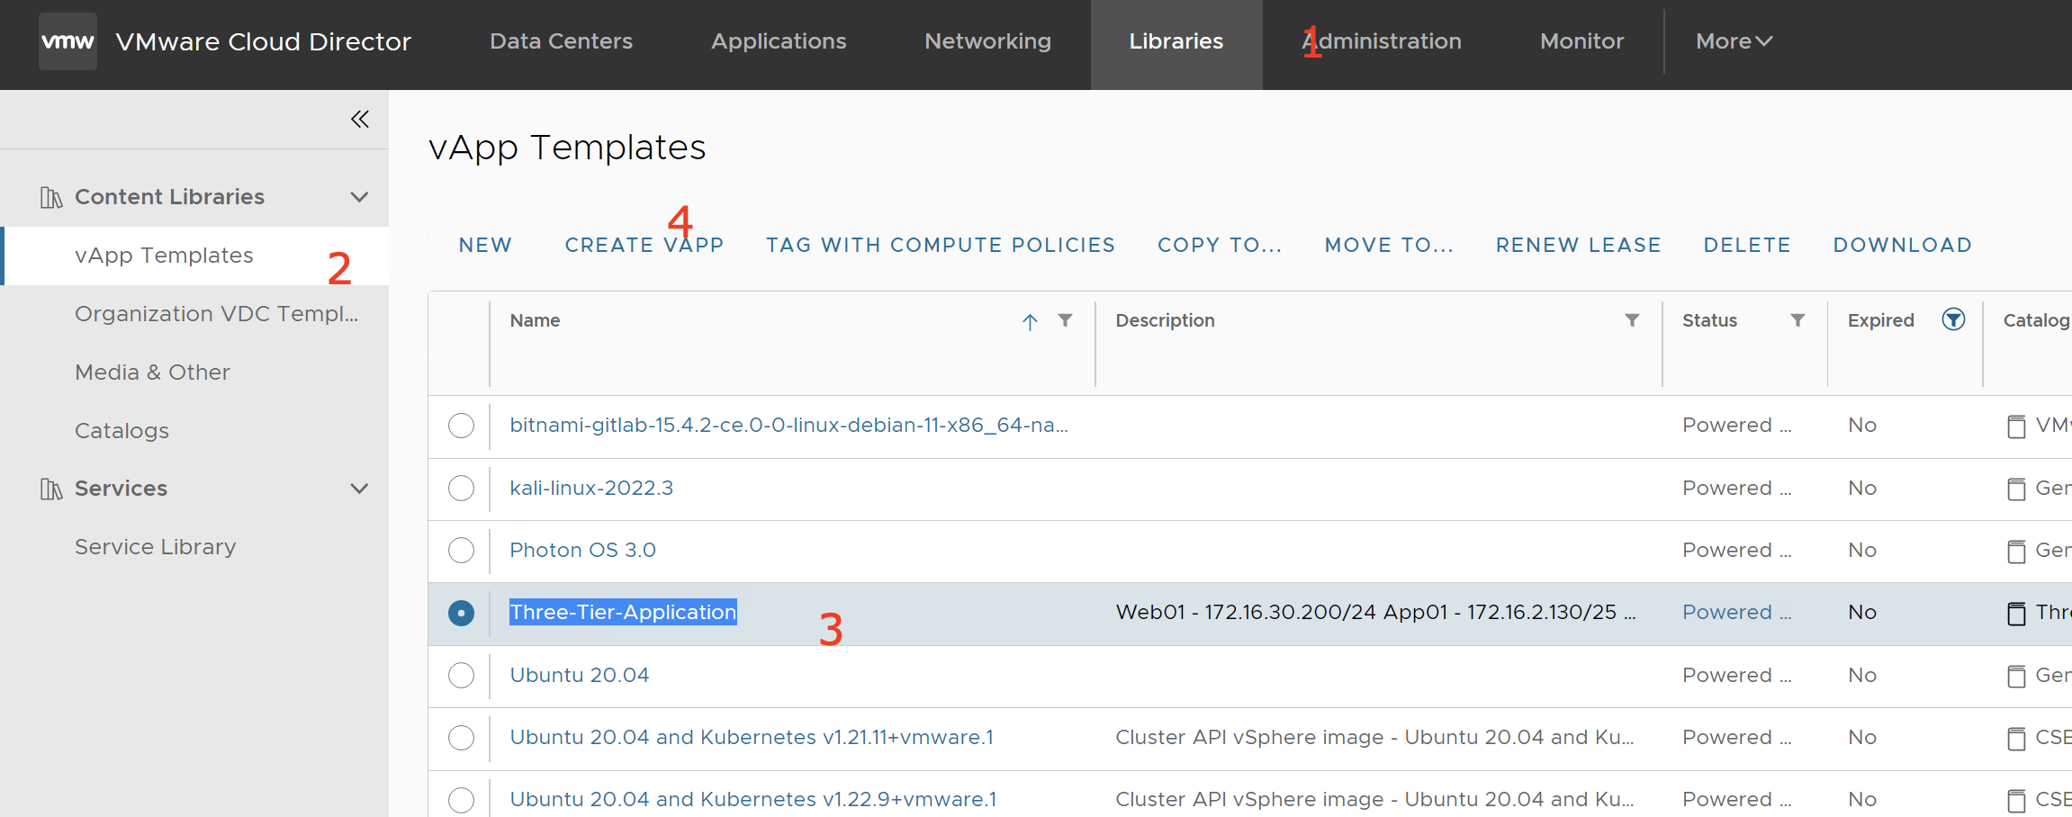

1. Enter a **name** and, optionally, a description of the vApp.

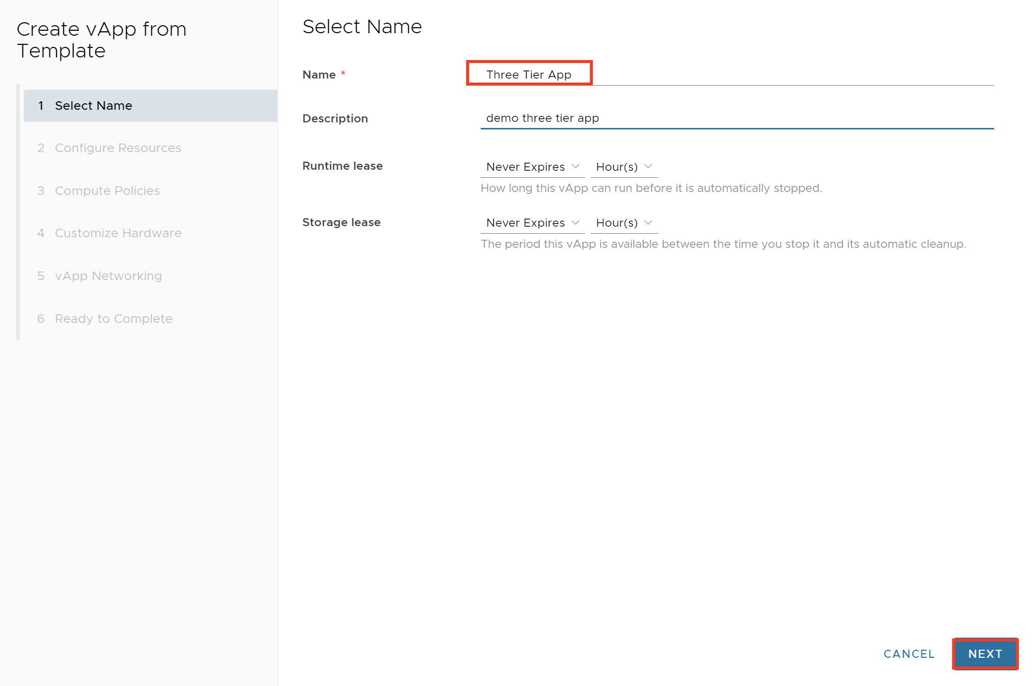

1. Select the virtual data center in which you want to create the vApp and select a storage policy.

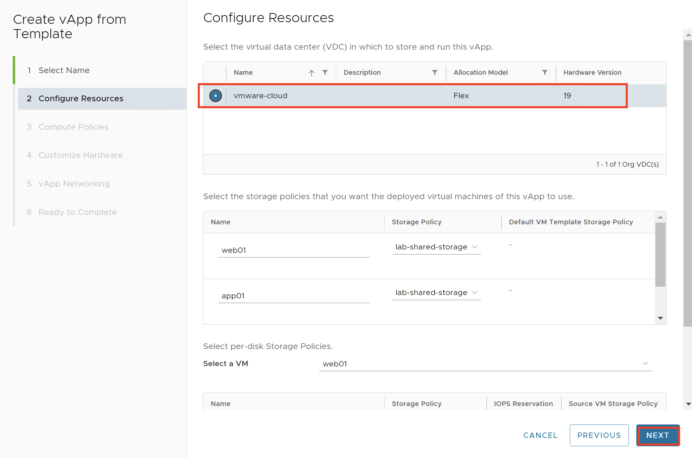

1. Leave compute policies as **default. (TKG small)**

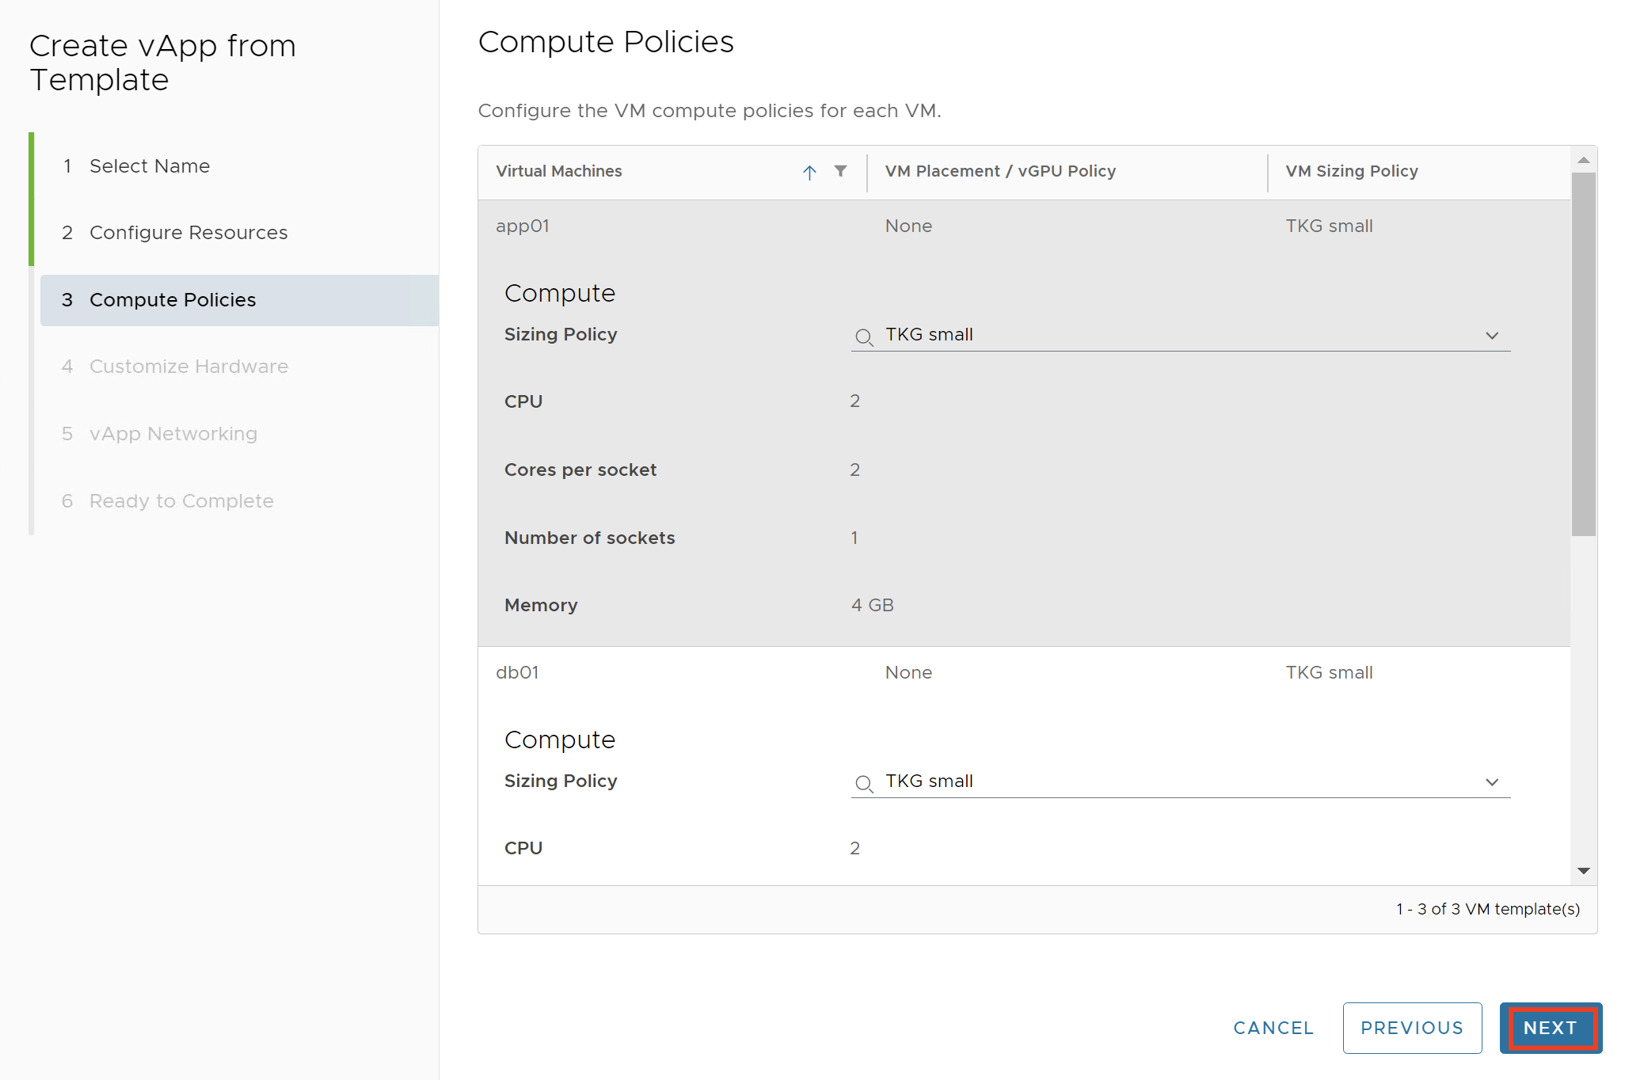

1. Customize the hardware of the virtual machines in the vApp and click Next.
2. Select “Configure VM Networking” toggle to enter manually additional network settings such as primary NIC, network adapter type, network, IP assignment and IP address settings for each virtual machine in the vApp.

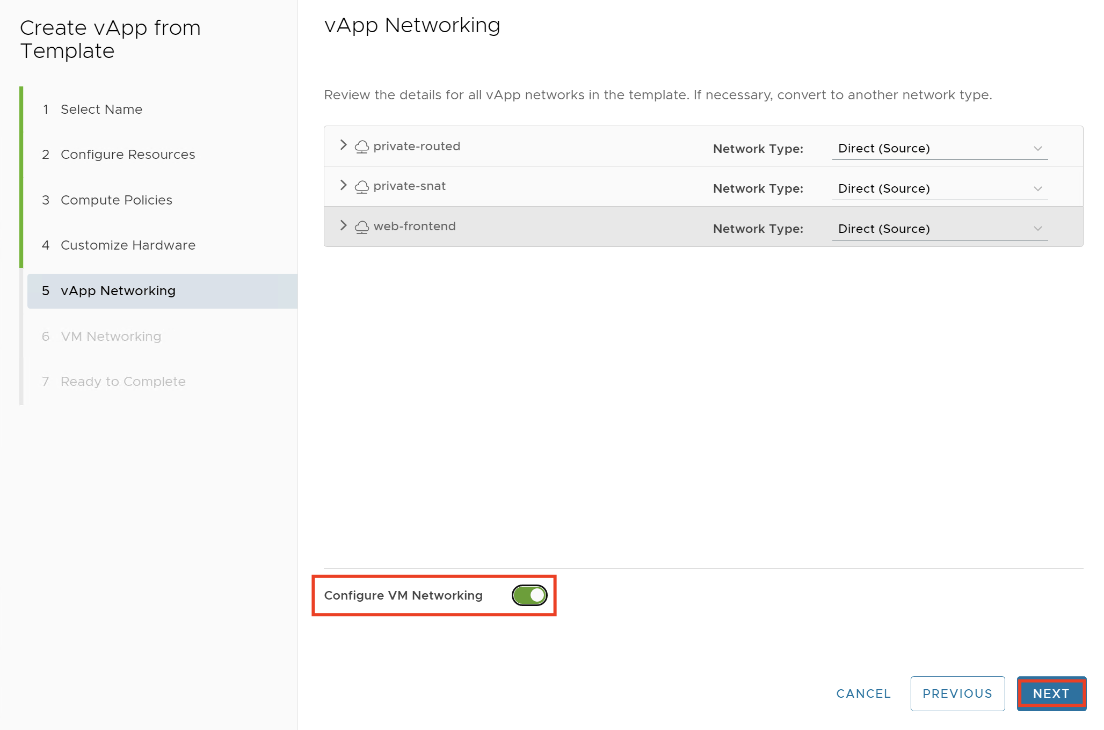

1. On the “VM Networking” Screen, change below settings:

|  |  |  |
| --- | --- | --- |
| Virtual Machine | IP Assignment | IP Address |
| App01 | Manual IP | 172.16.2.130 |
| Db01 | Manual IP | 192.168.200.100 |
| Web01 | Manual IP | 172.16.30.200 |

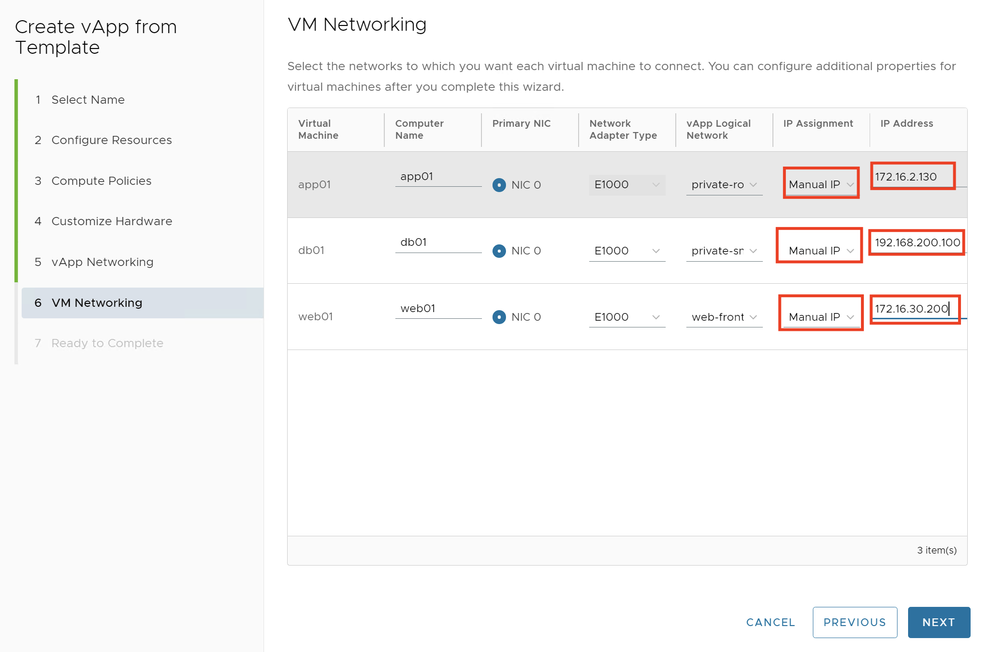

1. Review and finish

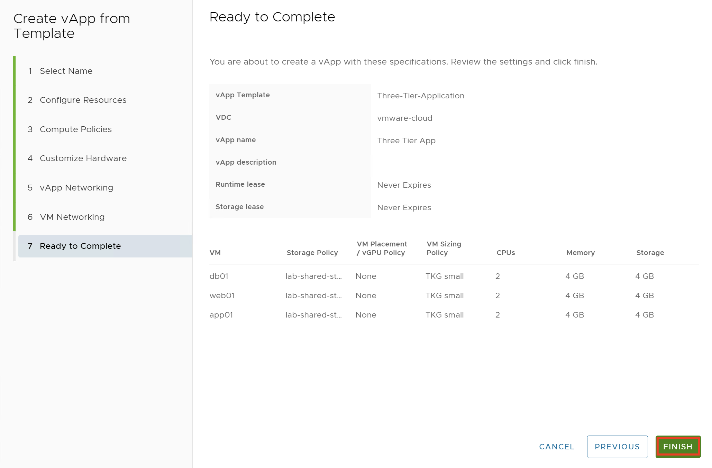

1. Power on the vApp

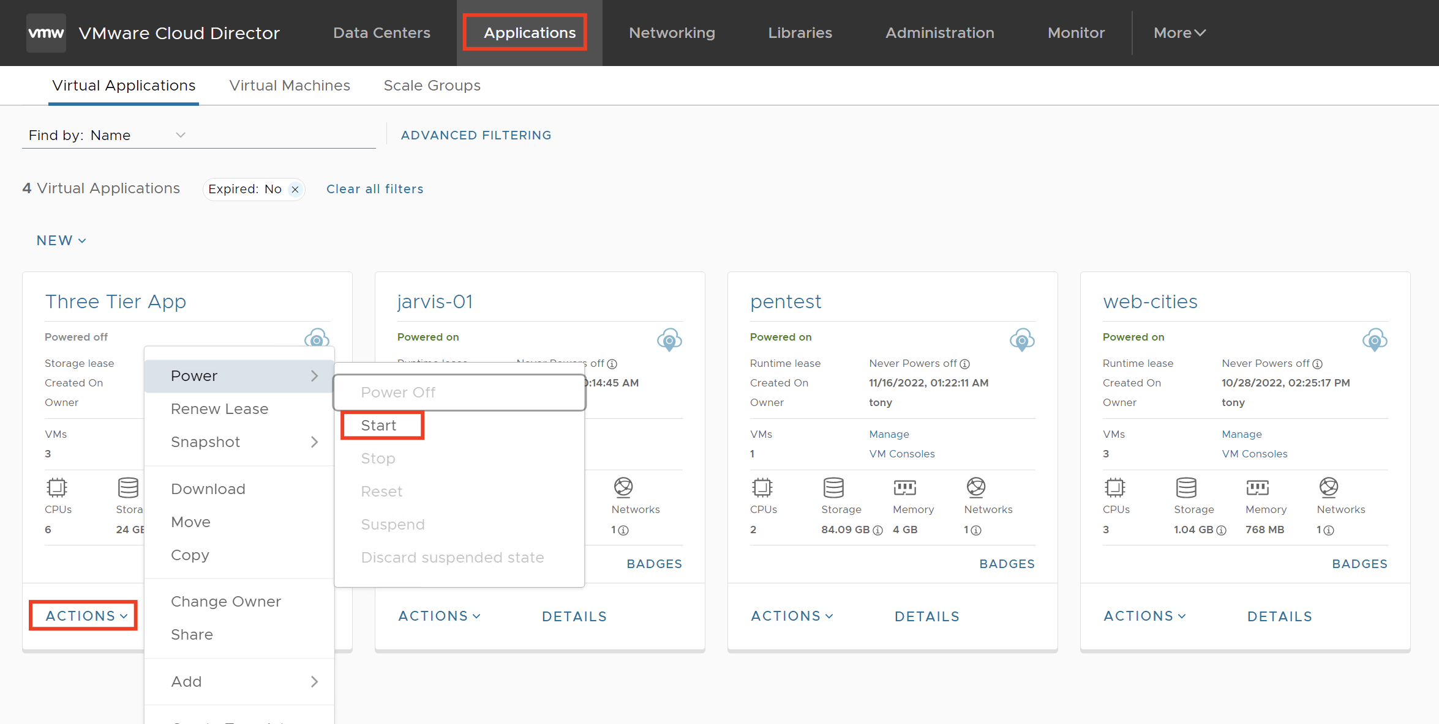

1. Now take the IP address of the Web VM and browse http://<IP address of Web VM> (http:// 172.16.30.200). can you access the webpage?
2. You will not be able to access from your desktop that desktop is not having routing connectivity to the web network, to able to access the web, you need to create a DNAT rule on Edge (NAT Gateway)

# Task:3 - Create DNAT rule to access web interface of Three Tier App (DNAT rule -outside going inside)

1. In the top navigation bar, click **Networking** and click the **Edge Gateways** tab.
2. Click the **edge gateway** **(stark-gateway)** and, under Services, click NAT.
3. To add a rule, click **New**.

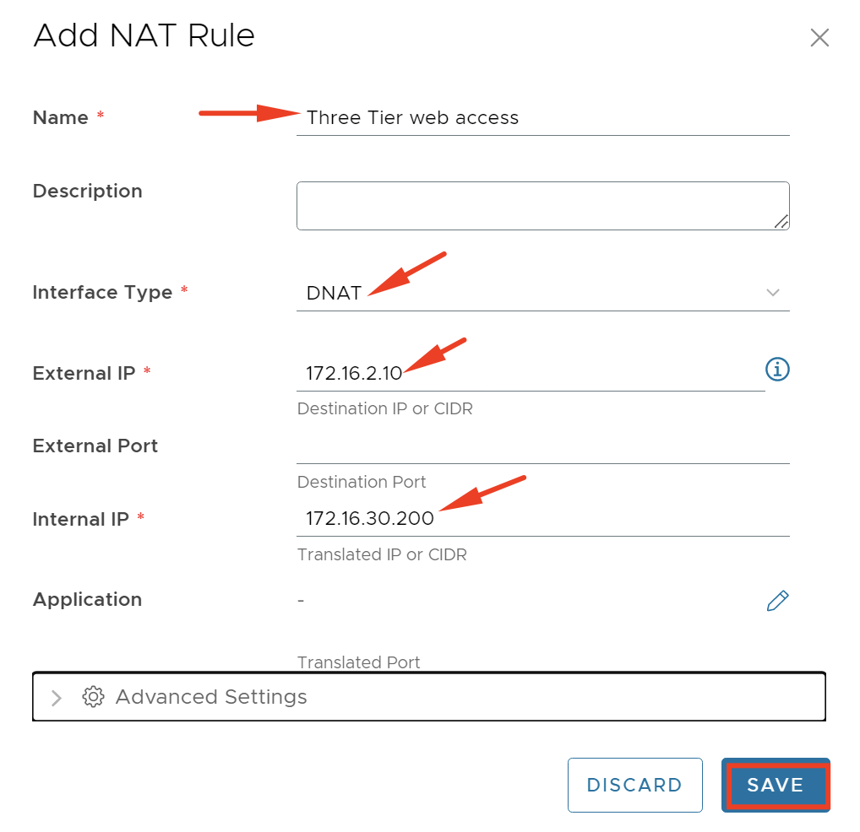

1. Click Save
2. Now if you try to access the web by using NAT address – <http://172.16.2.10>, now you should be able to access the website.

# Lab 2 - Creating and Managing a Shared Named Disk

**Objective**: Create, attach, and detach a shared named disk to multiple VMs:

# Task 1: Create a Shared Named Disk

1. Select VCD Primary > Provider from the bookmark and click SA-VCD-P Provider.
2. Log in to the Tenant portal using <https://vcd.tanzu.lab/tenant/stark>

* Username: administrator
* Password: VMware1!

1. You are logged in as a system administrator. The organization page appears by default.
2. Click the **vmware-vcd** card.
3. Click **Named Disks** under Storage in the left pane.
4. Click **NEW**.
5. Configure the named disk on the in the Create Named Disk window and then click **SAVE**.

|  |  |
| --- | --- |
| **Option** | **Action** |
| **Name** | Enter **SharedDisk-01** in the text box. |
| **Storage Policy** | Verify that **lab-shared-storage** is selected. |
| **Size of Disk** | Enter **1** and select **GB** from the drop-down menu. |
| **Bus Type** | Verify that **SCSI** is selected. |
| **Sharing Type** | Select **Disk** from the drop-down menu. |

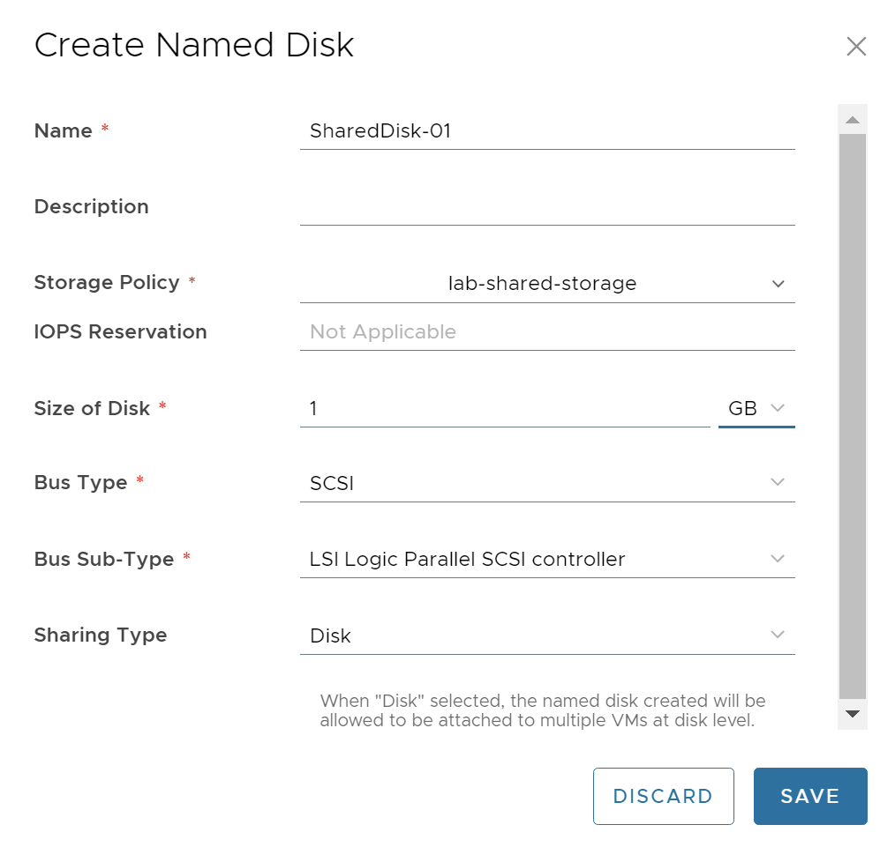

1. The SharedNamedDisk-01 appears with Attach VM Count as 0.

# Task 2: Attach a Shared Named Disk to a VM

You attach the shared named disk to multiple virtual machines at the same time as an organization administrator.

1. Power on the Cluster-Servers vApp completely.
   * Click **vApps** under Compute in the left pane.
   * Click **ACTIONS** on the Cluster-Servers vApp card.
   * Click **Power** and click **Start**.
   * Wait for the Cluster-Server vApp to power on before you proceed to the next step.

It takes 1 or 2 minutes for the vApp to power on completely.

1. Click **Named Disks** under **Storage** in the left pane.
2. Select **SharedDisk-01**.
3. Click **ATTACH**.
4. From the Virtual Machine drop-down menu, select **DB01**. **(Make sure you select VM DB01 which is in the capital latter)**
5. Click **ATTACH** and wait for the task to finish successfully. The Attached VM count changes from 0 to 1, Refresh the browser manually and observe the menu option. Only ATTACH and DETACH options are available. All the other options are unavailable.
6. When **SharedDisk-01** is selected, click **ATTACH**.
7. From the Virtual Machine drop-down menu, select **DB02**. You can also observe that **DB01** is not available in the list as the shared named disk is already attached to it.
8. Click **ATTACH** and wait for the task to finish successfully and Verify the Attached VM count changes from 1 to 2



1. Click the **“i”** icon next to **2** under the Attached VM Count column, to find the name of the VMs to which the SharedDisk-01 is connected. The column has DB01 and DB02.

# Task 3: Detach the Shared Named Disk

You detach the shared named disk attached to multiple virtual machines as an organization administrator.

1. Click Named Disks under Storage in the left pane.
2. Select SharedDisk-01.
3. Click DETACH.
4. In the Detach Shared Named Disk window, select DB02 from the Virtual Machine drop-down menu
5. Click DETACH and wait for the task to finish successfully. Verify the Attached VM count changes from 2 to 1.
6. Power off the vAPP

# Lab 3 - Creating and Managing a Distributed Firewall Rules

**Objective**: Micro-Segmentation

You can define dynamic security groups of virtual machines based on specific criteria to which to apply distributed firewall rules.

# Task-1: Create Dynamic Groups

1. In the top navigation bar, click **Networking** and then click the **Data Center Groups** tab. The list of data center groups appears.
2. Click the “**Data Center Group 01**” data center group.
3. Click **Edge Gateway** and then click **Add Edge**.
4. Select available edge gateways and click **Save**
5. Under Security, click **Dynamic Groups** and click **New**.
6. Enter a **Name** and, optionally, a description for the dynamic security group.
7. To create a criterion for inclusion in the group, add up to four rules that apply either to a VM name or to a VM security tag. create Two Dynamic Groups as per below table:

|  |  |  |
| --- | --- | --- |
| Type | Operator | Value |
| VM Name | Contains | app01 |
| VM Name | Contains | db01 |
|  |  |  |

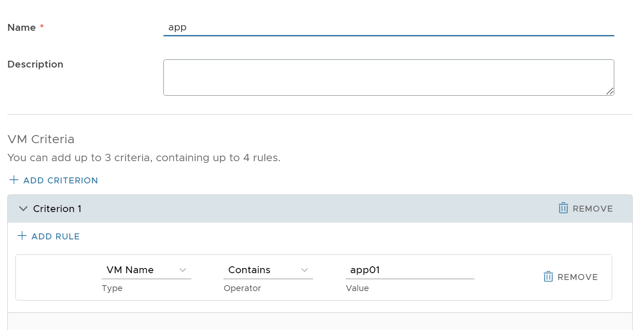

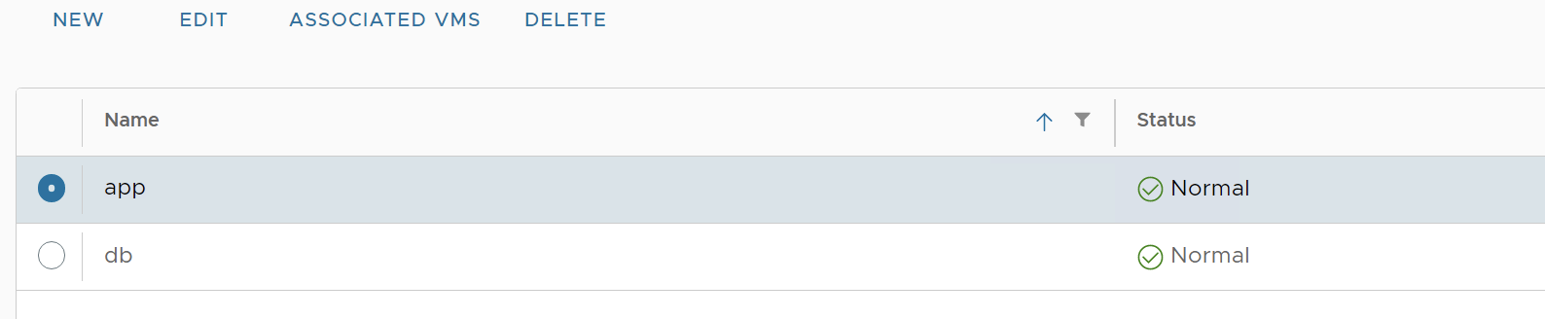

1. You can observe that the dynamic group automatically picked up Virtual Machines whose names start with app01 and db01

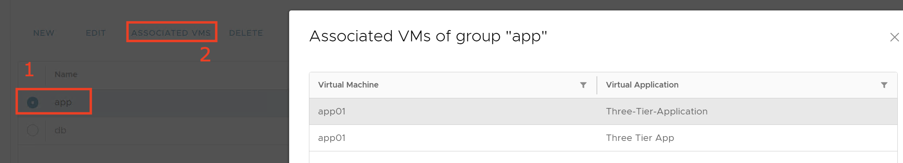

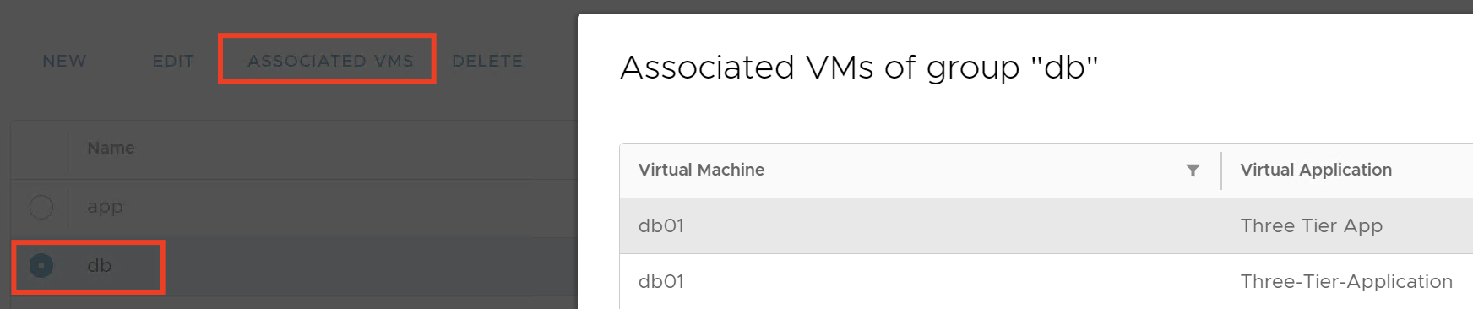

# Task-2: Create Distributed Firewall Rule

The distributed firewall rules that you create apply only to workloads that are attached to the data center group networks.

1. In the top navigation bar, click **Networking** and then click the **Data Center Groups** tab. The list of data center groups appears.
2. Click the “**Data Center Group 01**” data center group.
3. Click the Distributed Firewall tab on the left.
4. Click Edit Rules
5. To add a firewall rule, click New on Top.

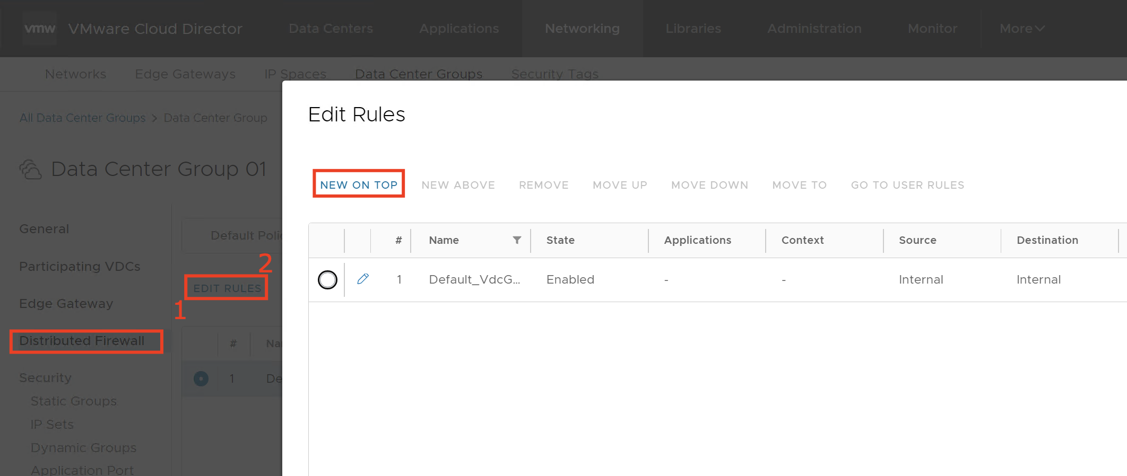

|  |  |  |
| --- | --- | --- |
| Name | Value |  |
| Name | App-DB-Block |  |
| State | enable |  |
| Source | Select “app” | group created in Task1 |
| Destination | Select “db” | group created in Task1 |
| Action | Select “Drop” |  |
| IP Protocol | IPv4 |  |

1. Click Save.

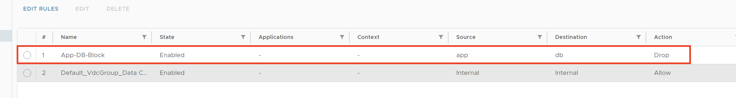

1. Now browse the three-tier app webpage from your control center machines by going to <http://172.16.2.10/>, above firewall rule must have broken the connection between App and DB and the webpage continues to wait for a response.
2. Again, edit the firewall rule, and instead of “Drop” select “Allow” or delete the firewall rule, now again refresh the webpage (<http://172.16.2.10>), and you should see a response.

This completes the Micro-segmentation Lab.

# Lab-4 - Creating and Managing the Auto Scaling Groups

**Objective and Tasks:** Create the Auto Scale group depending on the predefined criteria to automatically scale the number of VMs.

# Task 1: Configure Auto Scale

1. From the top navigation bar, select **Applications**and select the **Scale Groups** tab.
2. Click **New Scale Group**.
3. Select an organization VDC – in the Lab choose “**vmware-cloud**”.
4. Enter a name and, optionally, a description of the new scale group.
5. Select the min VMs **one** and max VMs **Two**, and click Next.

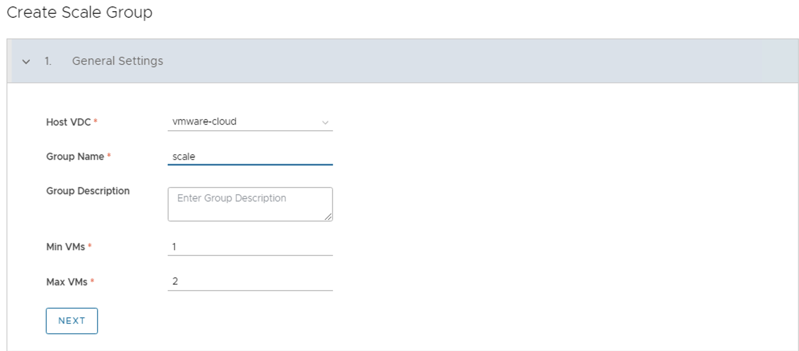

1. Select a VM template – **“web-nyc”** for the VMs in the scale group and a storage policy **“lab-shared-storage”**, and click **Next**.

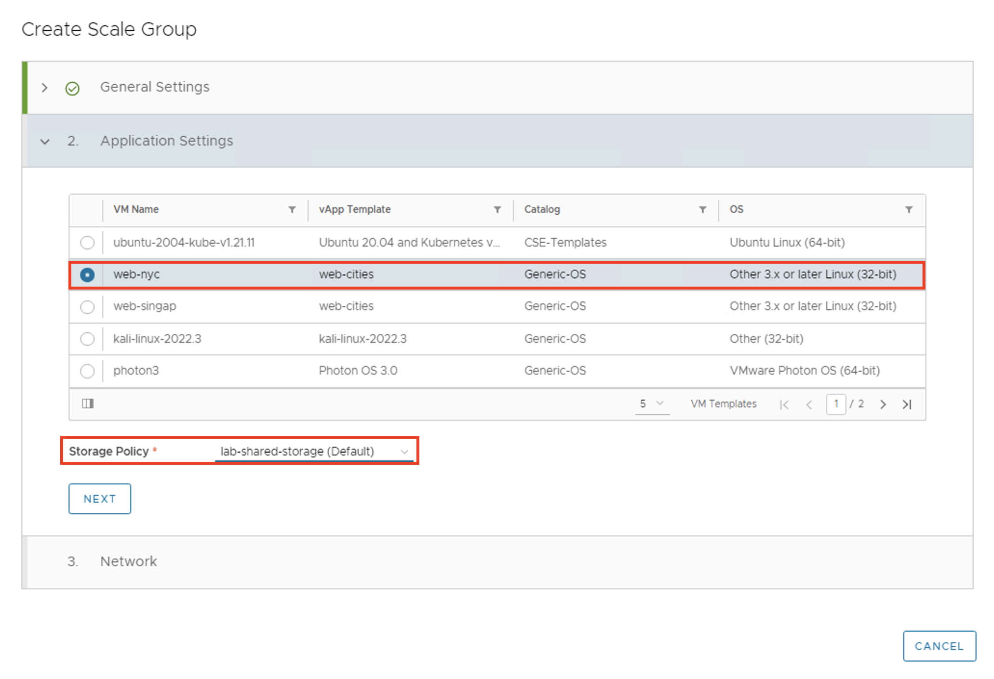

1. Select a network for the scale group.
   * select **I have a fully set-up network**.
   * Select Network **“Web-Frontend”**

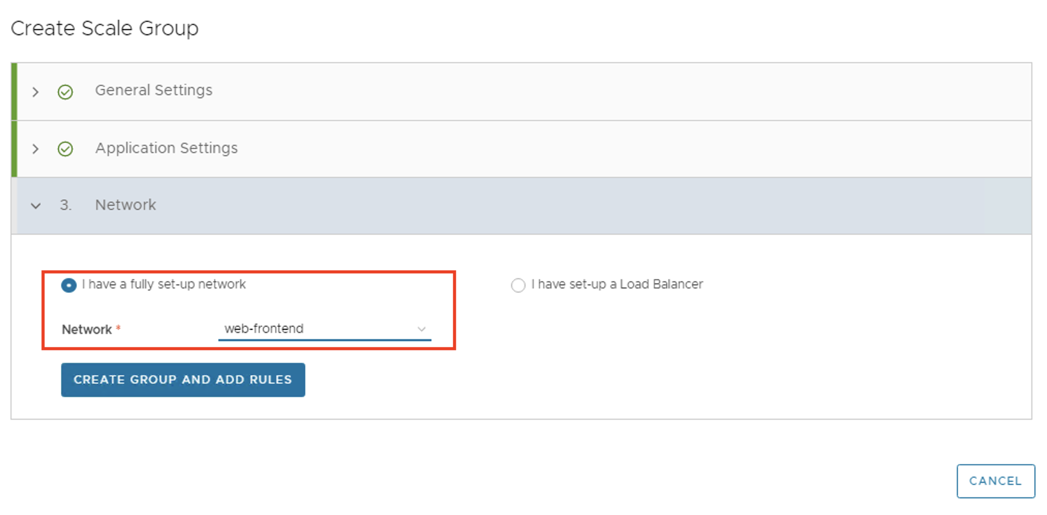

1. Click Create Group and Add Rules.

# This will start provisioning the initial VM, while it creating the VM, you can proceed to create Add an Auto Scaling Rule

# Task 2: Add an Auto-Scaling Rule

1. From the top navigation bar, select **Applications** and select the **Scale Groups** tab.
2. Select a scale group and select **Rules**.
3. Click **Add Rule**.
4. Configure Rule as per the below Screenshot

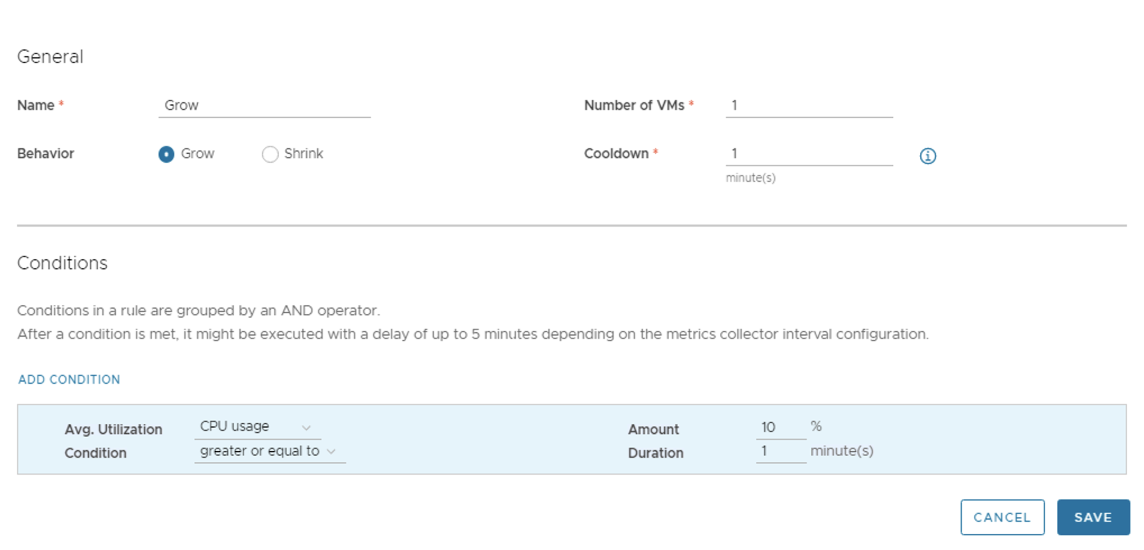

1. Add another rule for Shrink by following the below screenshot

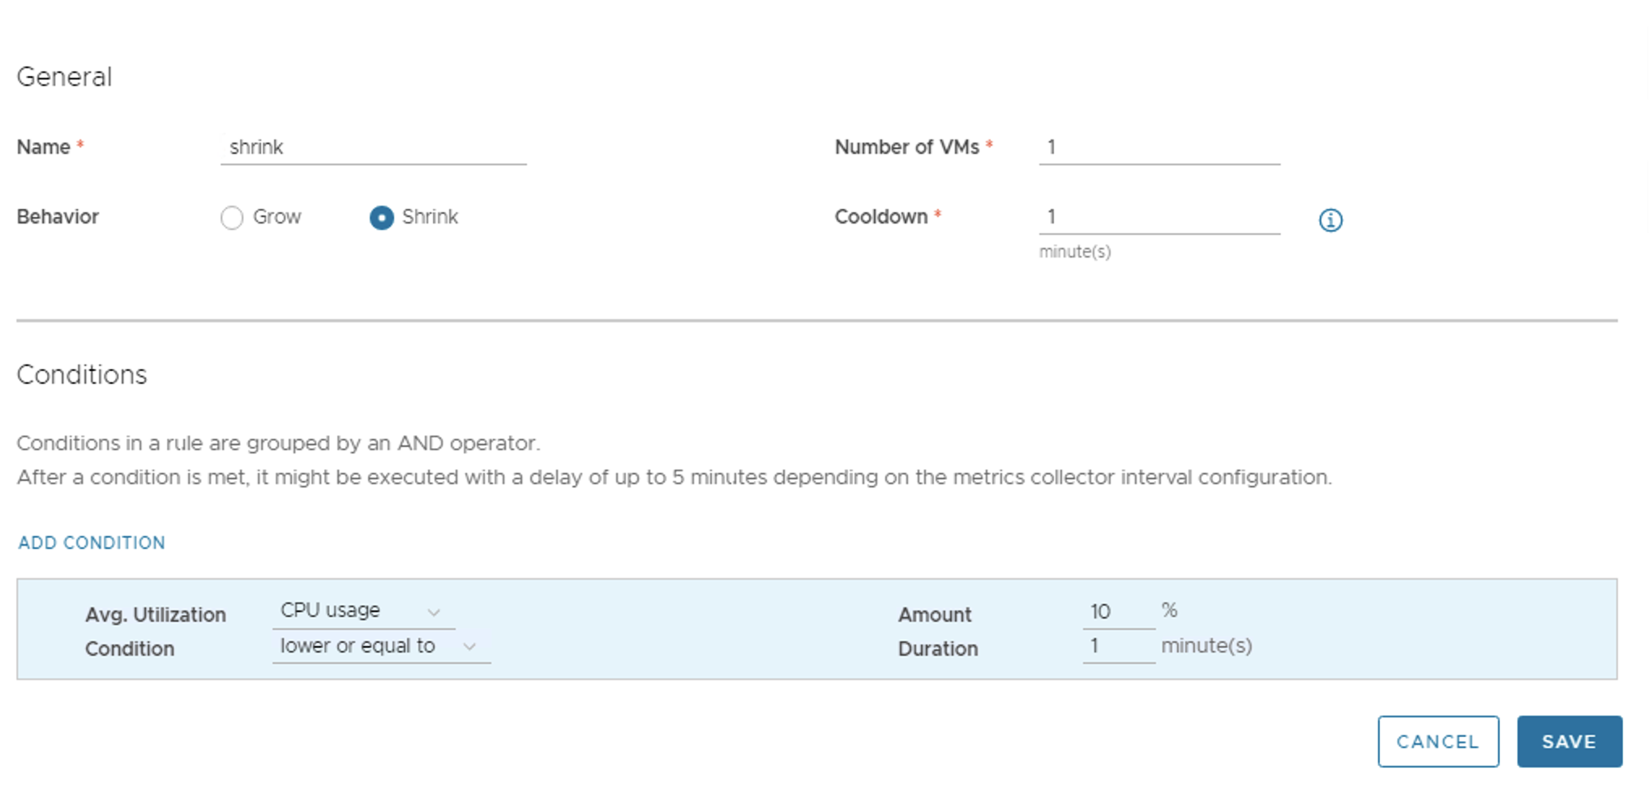

Now take the console of the first VM which was deployed as part of the Initial auto-scale grow task and run command **#cat /dev/zero > /dev/null**, This command will increase CPU and Memory usage of the VM and will trigger scale rule to auto-scale VM.

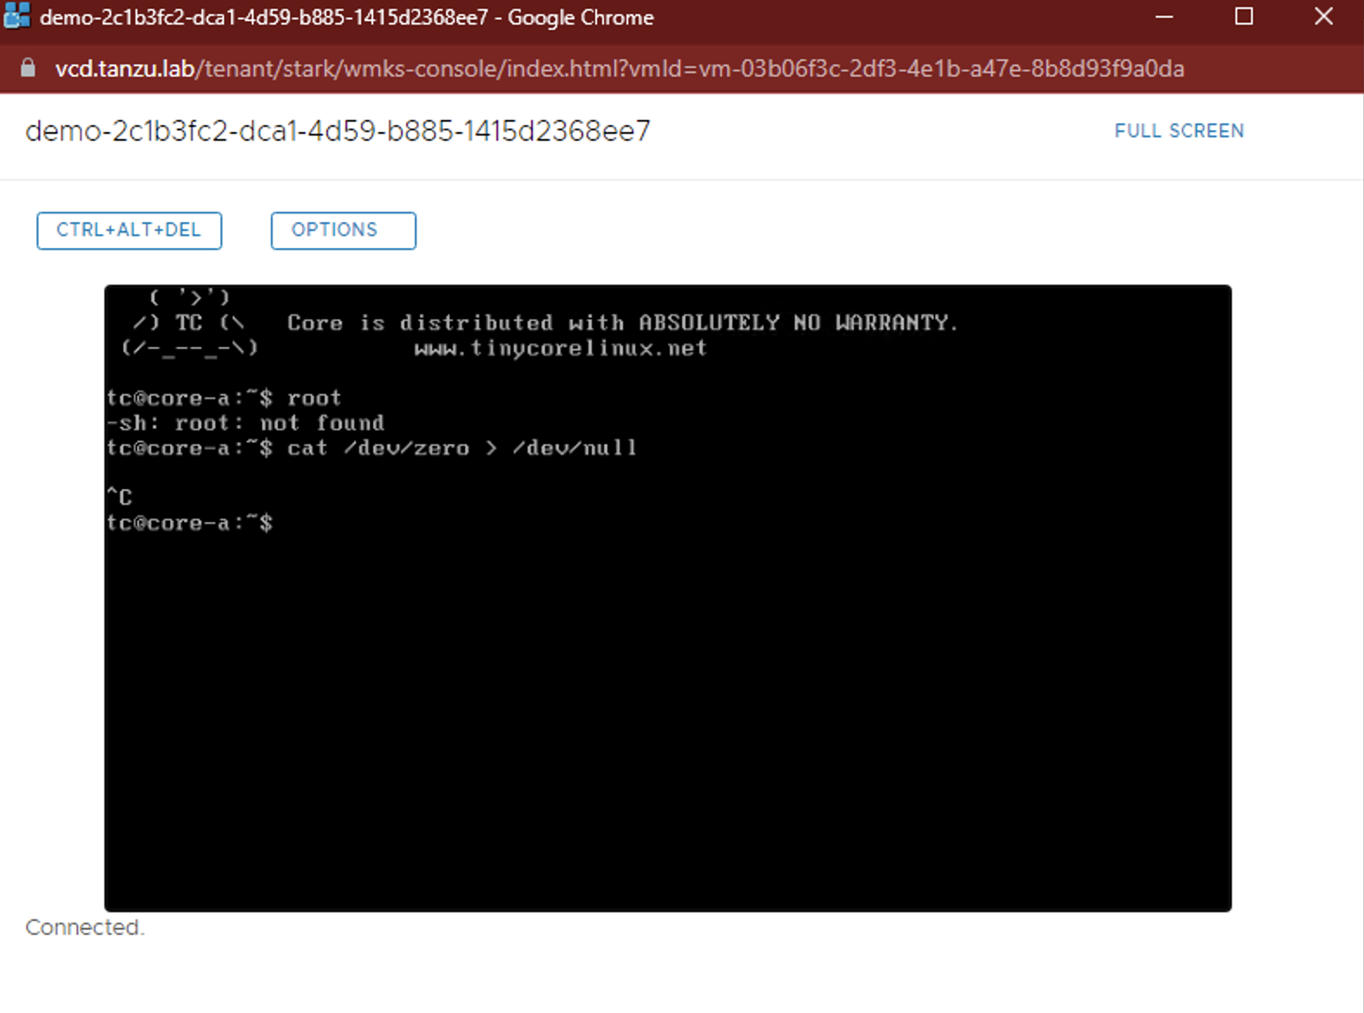

Observe Scale behaviour in your vCD console taskbar or by going into Scale Group:

1. From the top navigation bar, select **Applications** and select the **Scale Groups**
2. Select a scale group and select **Monitor**

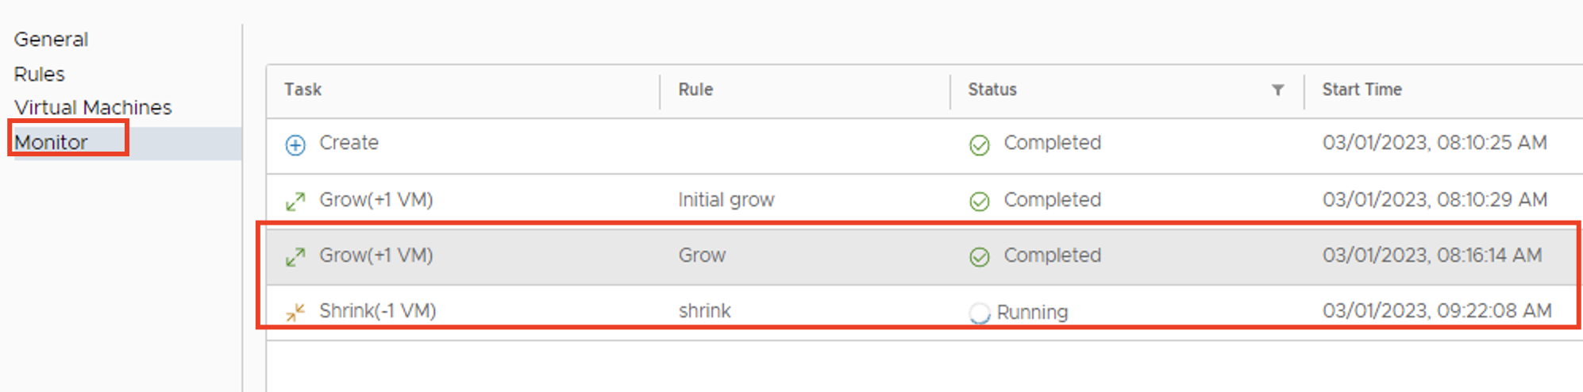

Once grow operation is completed, Stop the running Job on the VM, and wait, you should see the “shrink” task initiated, and will delete extra VMs as per the rule defined.

**Day -2 Labs**

# Lab-1 - Create a VMware Tanzu Kubernetes Grid Cluster

**Objective and Tasks:** Create Tanzu Kubernetes Grid clusters by using the Kubernetes Container Clusters plug-in.

# Task 1: Create a Tanzu Kubernetes Cluster

1. Log in to VMware Cloud Director tenant URL - <https://vcd.tanzu.lab/tenant/stark/login>
2. From the top navigation bar, select **More** > **Kubernetes Container Clusters** > **New**.
3. Select the **VMware Tanzu Kubernetes Grid** runtime option, and click **Next**.
4. Enter the name **“tk8s”** and select a Kubernetes Template (**1.5.4-v1.22.9+vmware.1**) from the list, and click **Next**.

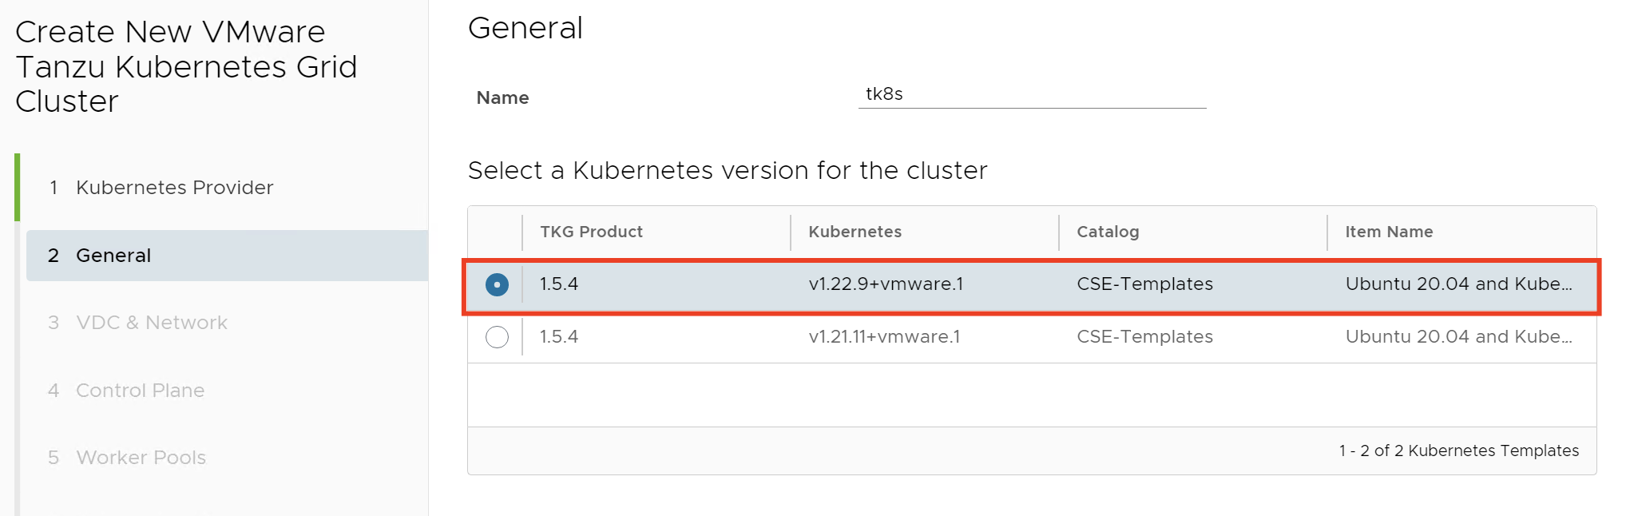

1. In the VDC & Network window, select the organization VDC **“vmware-cloud”** and select VDC network as **“private-snat”** for the cluster, and click Next.

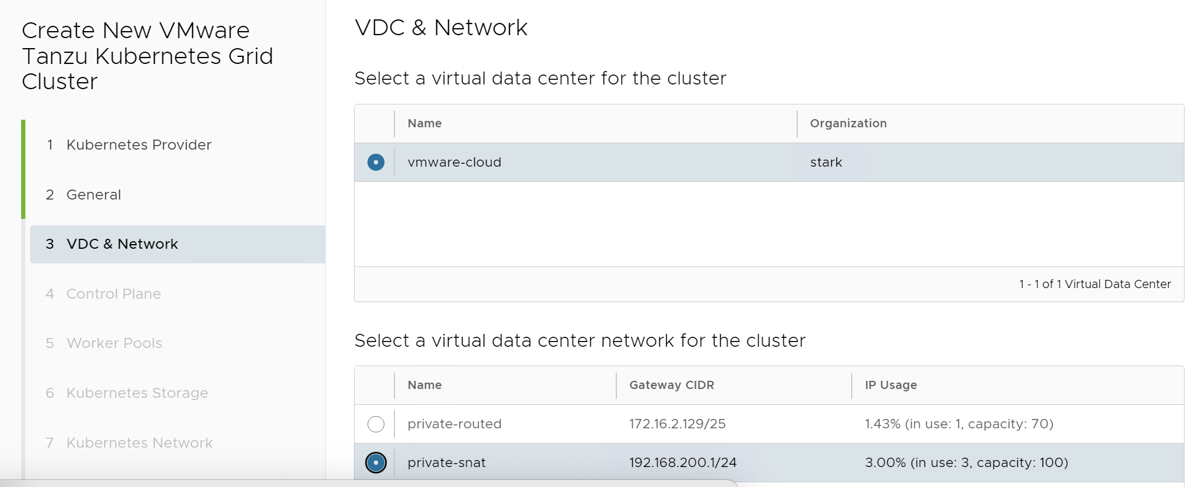

1. In the Control Plane window, select the number of master nodes as **“1”,** leave disk size as it is, and select the sizing policy as **“TKG Small”** and storage policies as **“lab-shared-storage”** and click Next.

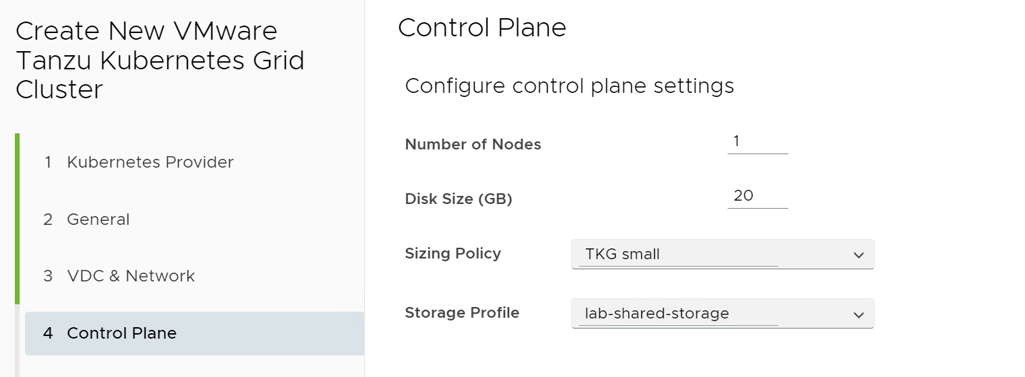

1. In the **Worker Pools** window, select the number of nodes as **“1”**, leave disk size as it is, and select the sizing policy as **“TKG Small”** and storage policies as “**lab-shared-storage**” and click Next.

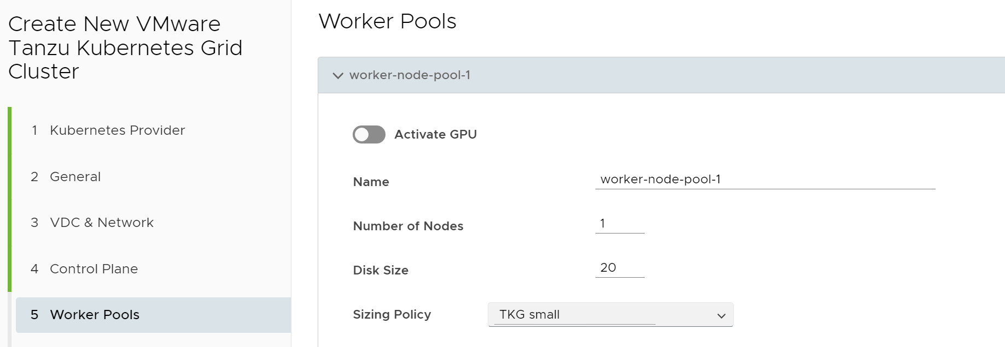

1. In the **Kubernetes Storage** window, activate the **Create Default Storage Class** toggle, select the storage profile **“lab-shared-storage”**, and leave everything as **“Default”**.

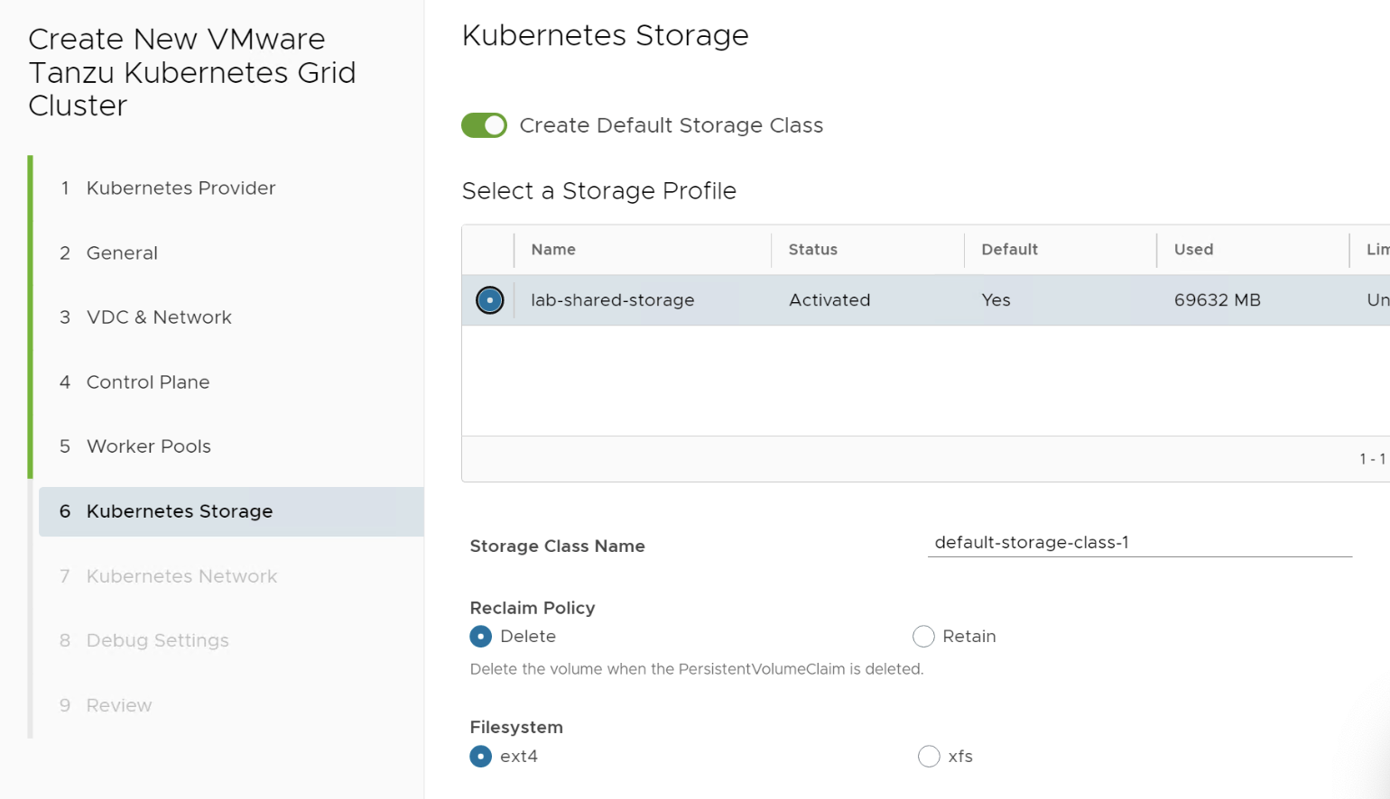

1. In the **Kubernetes Network** window, leave IP addresses for Kubernetes services and a range for Kubernetes pods as default, and click **Next.**
2. In the **Debug Settings** window, activate **Auto Repair on Errors** toggle and Click **Next**.
3. Review the cluster settings, and click **Finish**.

This Cluster creation task will take some time, we will move ahead with **Task:2** with an existing cluster named **“k8s01”**

# Task 2: Connect to Tanzu Kubernetes Cluster

1. Select cluster “k8s01” and click on “DOWNLOAD KUBE CONFIG”. This will download K8s cluster file onto your desktop.

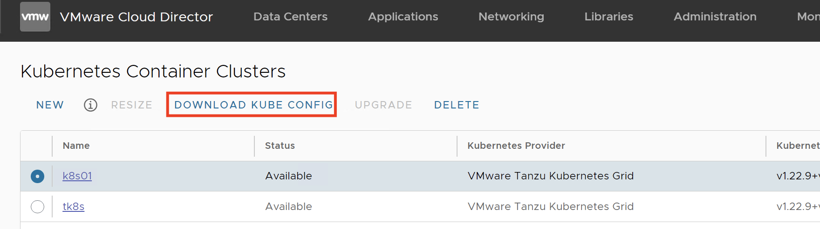

1. Move config file from desktop to jump server
   1. Use WinSCP on your desktop and connect to IP **172.16.2.11**, Username-**root** & Password -**VMware1!**
   2. Copy downloaded kubeconf file to /tmp folder
   3. From Desktop SSH to IP **172.16.2.11 (jump server),** Username-**root** & Password -**VMware1!**
   4. And move the copied file from /tmp folder to the correct location with the correct name, using the below command:
      1. #mv /tmp/kubeconfig-k8s01.txt ~/.kube/config
2. Run the below command to check the status of nodes:
   * 1. #kubectl get nodes
3. if you have done all the above steps correctly then you should see K8s nodes as below



# Task 3: Deploy an Application and access it from the control center

1. Log in to VMware Cloud Director tenant URL - <https://vcd.tanzu.lab/tenant/stark/login>
2. From the top navigation bar, select **More** > **App Launchpad**
3. Go to **Marketplace** and Click **“LAUNCH”** on **“NGINX Open Source Helm Chart packaged by Bitnami 1.23.1\_6\_r14”**
4. Enter a name for the application as “nginx”
5. Select the target Kubernetes cluster **Tanzu Lab-CAPVCDCluster-vmware-cloud-k8s01**

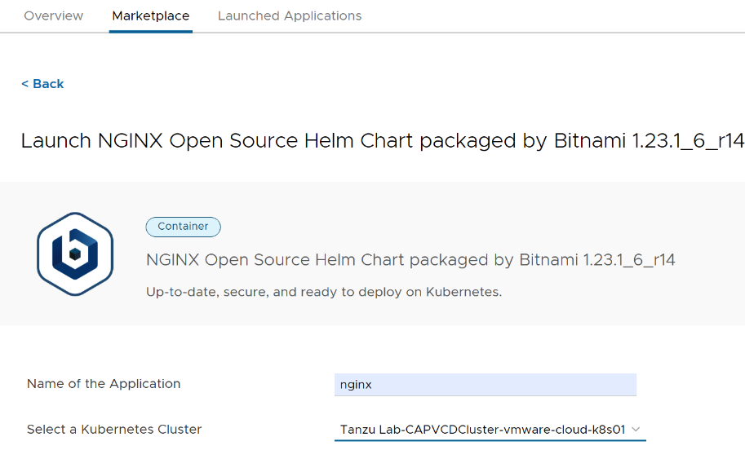

1. Click **Show Advanced Settings**.
   1. Make sure the Service Type is **LoadBalancer**
2. Click **Launch** and wait for a few minutes, process will automatically create LB VIP, Pool, and NAT rules so that you can access them from outside
3. Click on the **Launched Application,** note the external IP which should be **172.16.2.x**

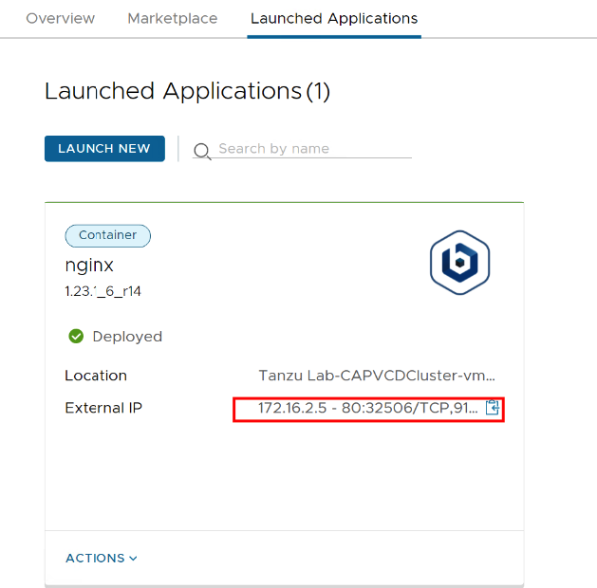

1. Browse **http://172.16.2.x,** this should open nginx webpage

**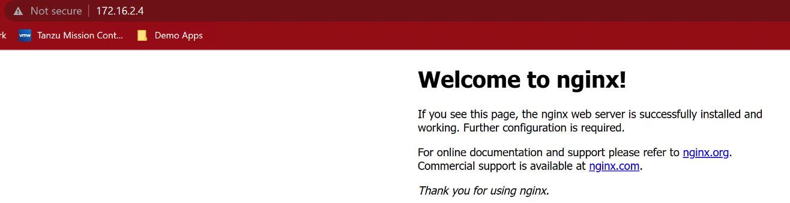**

# Task 4: Deploy an Application (kubeapps) and access it from the control center

1. Log in to VMware Cloud Director tenant URL - <https://vcd.tanzu.lab/tenant/stark/login>
2. From the top navigation bar, select **More** > **App Launchpad**
3. Go to **Marketplace** and Click **“LAUNCH”** on **“Kubeapps Helm Chart packaged by Bitnami”**
4. Enter a name for the application as “**kubeapps**”
5. Select the target Kubernetes cluster **Tanzu Lab-CAPVCDCluster-vmware-cloud-k8s01**

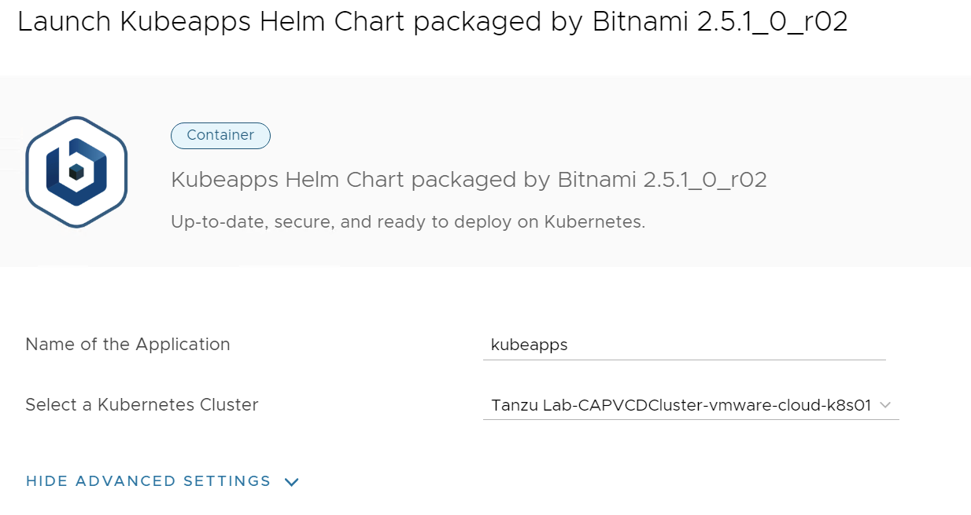

1. Click **Show Advanced Settings**.
   1. Change Service Type as **LoadBalancer** instead of **ClusterIP**

**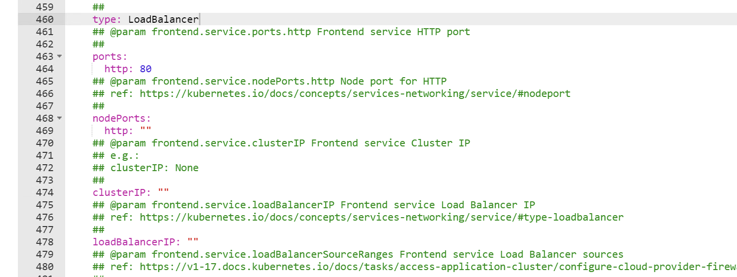**

1. Click **Launch** and wait for a few minutes, process will automatically create LB VIP, Pool, and NAT rules so that you can access them from outside
2. you can also check the status of pods by running the below command on jump hosts:

**#kubectl get pods**

1. Make sure all the **kubeapps** pods are running, go to **NAT,** and take note of the **NATED IP**

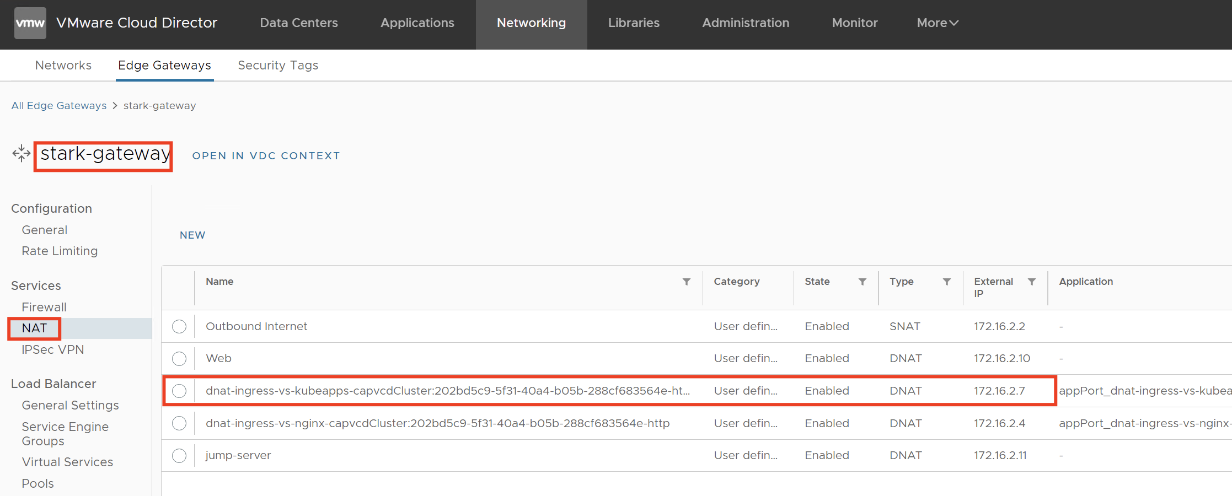

1. Browse the IP (Step: 9) from your desktop, you should see the below webpage



1. To access Kubeapps we can create a Kubernetes service account and use that API token to authenticate with the Kubernetes API server via Kubeapps:
   1. SSH to Jump server (172.16.2.11) and run command:
   2. #kubectl create --namespace default serviceaccount kubeapps-operator
   3. #kubectl create clusterrolebinding kubeapps-operator --clusterrole=cluster-admin --serviceaccount=default:kubeapps-operator
   4. cat <<EOF | kubectl apply -f - apiVersion: v1 kind: Secret metadata: name: kubeapps-operator-token namespace: default annotations: kubernetes.io/service-account.name: kubeapps-operator type: kubernetes.io/service-account-token EOF
2. Now to retrieve the token run:
   1. #kubectl get --namespace default secret kubeapps-operator-token -o go-template='{{.data.token | base64decode}}'
3. Copy generated token (Copy token carefully ensure content within red bracket must be copied)



1. Paste the token generated in the previous step to authenticate and access the Kubeapps dashboard for Kubernetes.

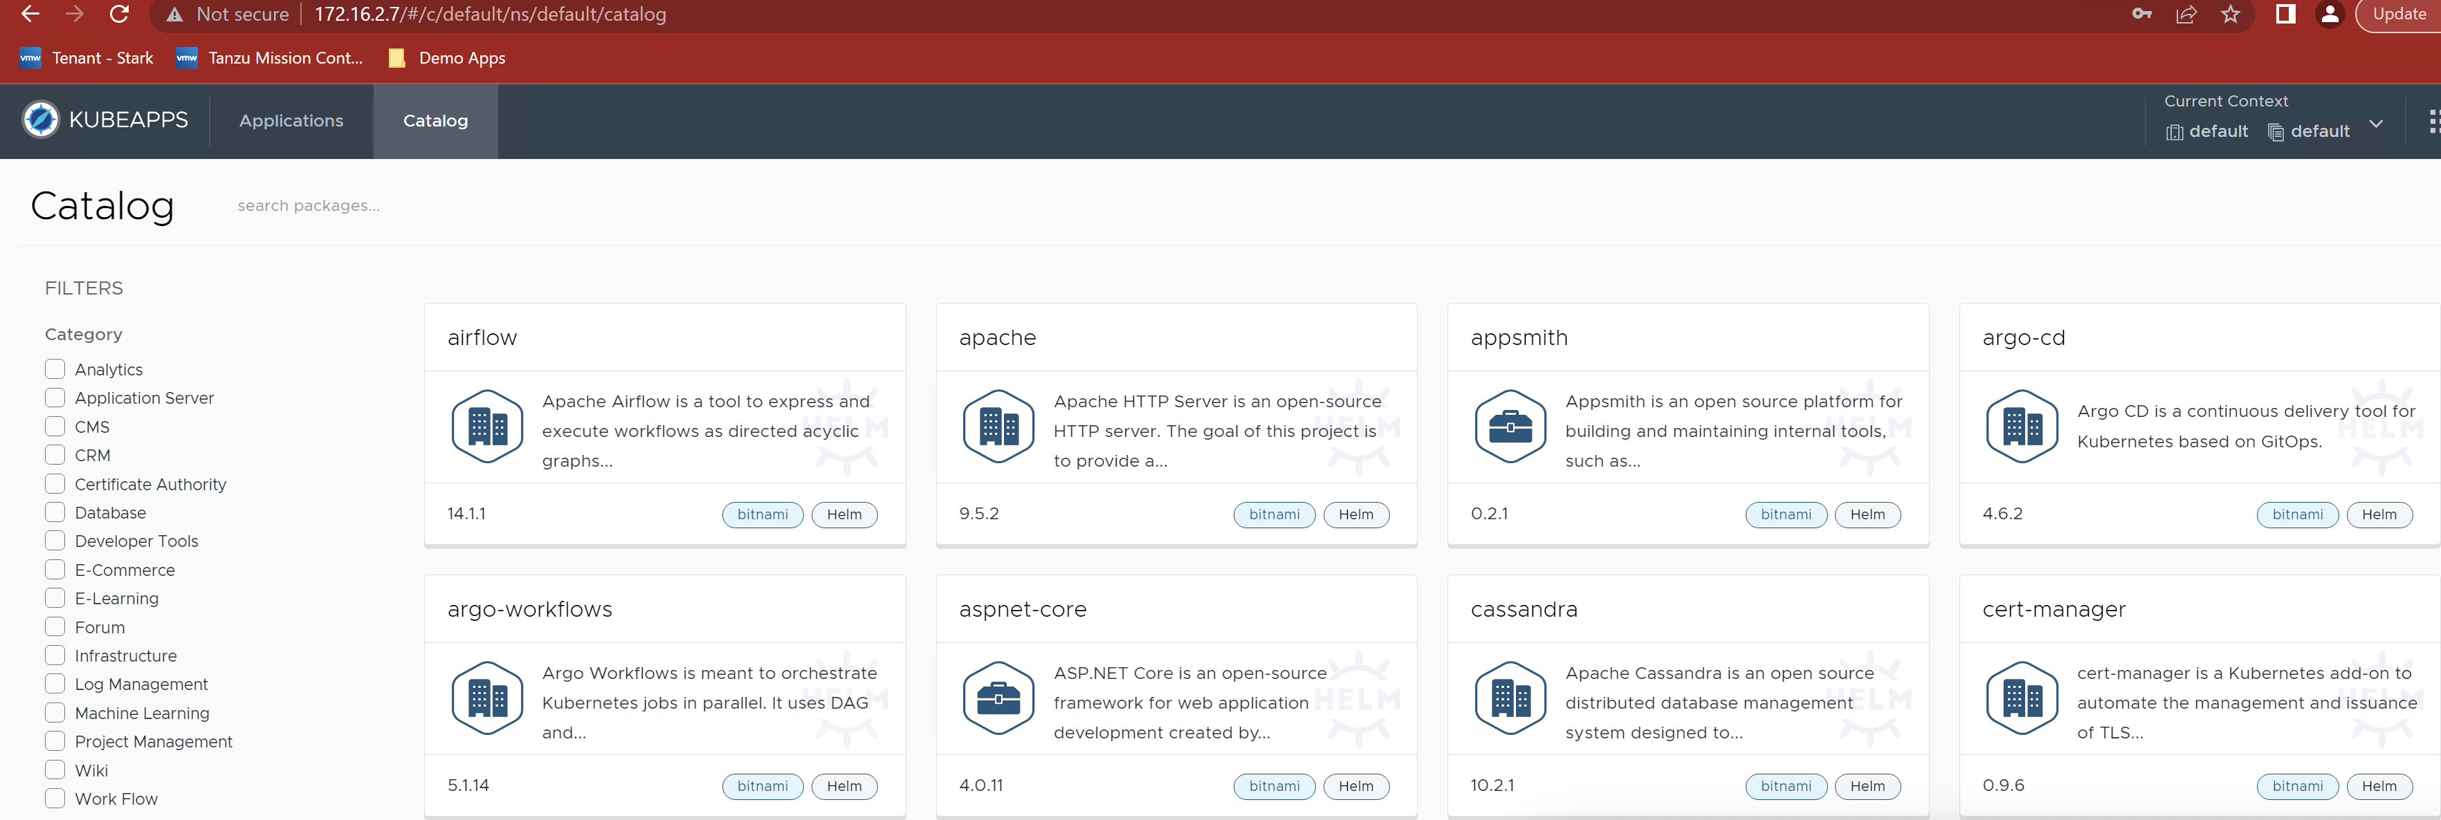

[Kubeapps](https://kubeapps.dev/" \o "Kubeapps. This link will open in a new tab" \t "_blank) provides a cloud-native solution to browse, deploy and manage the lifecycle of applications on a Kubernetes cluster. It is a one-time install that gives you a number of important benefits, including the ability to:

* browse and deploy packaged applications from public or private repositories
* customize deployments through an intuitive user interface
* upgrade, manage and delete the applications that are deployed in your Kubernetes cluster
* expose an API to manage your package repositories and your applications

# Task 5: DBaaS

**Tanzu Data Solutions - My SQL Deploy**

Log in to the VMware Cloud Director extension for Data Solutions from VMware Cloud Director using URL <https://vcd.tanzu.lab/tenant/stark/login> and

**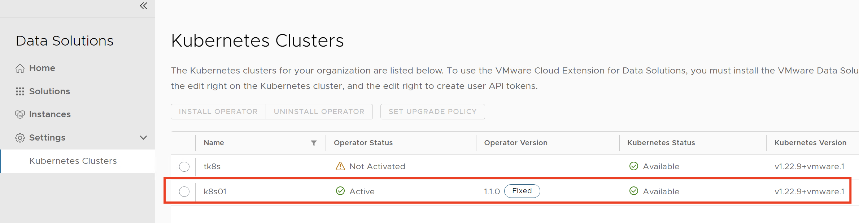**

1. Click **Instances** > **New Instance**.
   1. Enter the instance name - dsmysql
   2. Select the solution as - MySQL
   3. Select the Kubernetes cluster as K8s01
   4. Enter a user password as VMware@1234$
   5. Select a solution template as MySQL Minimal
   6. click **Show Advanced Settings and select “Expose Service by Load Balancer”**
   7. click Create

**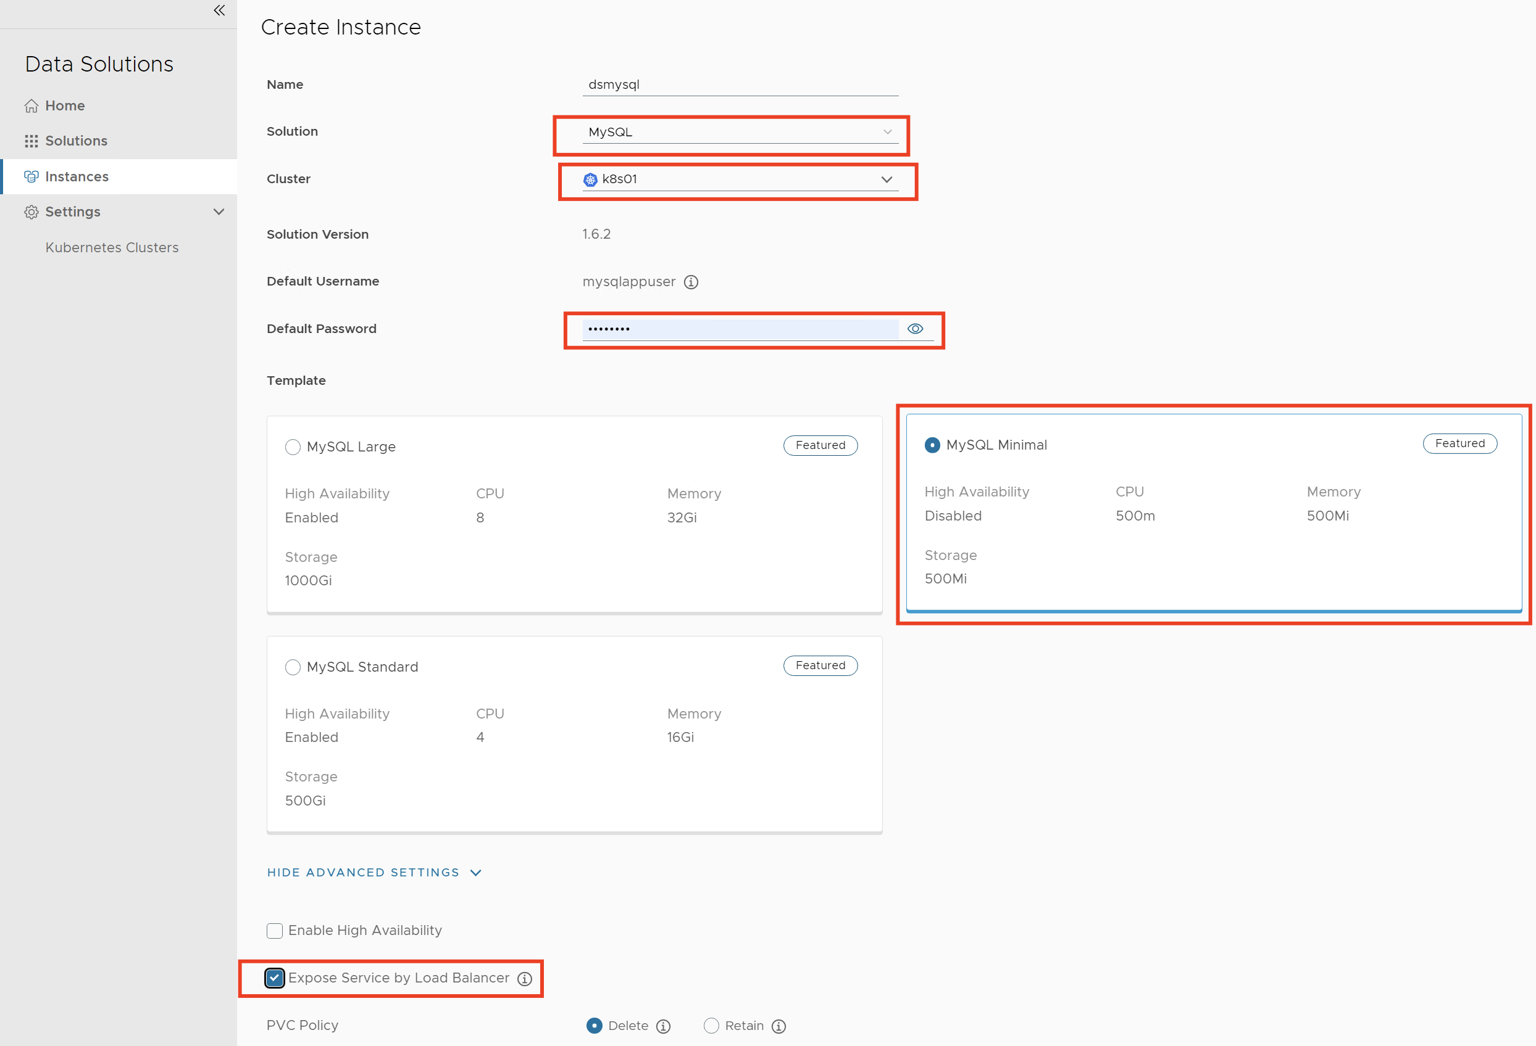**

Continue to see in vCD taskbar, it is automatically creating required persistent volumes as well as Network services

**Tanzu Data Solutions – Connecting to My SQL Database**

Open MySQL Workbench and create a new connection by entering:

**Host Name:** Get the IP address under Overview by clicking on the deployed mysql instance

**Port:** 3306

**Username:** mysqlappuser

**Password:** VMware@1234$

**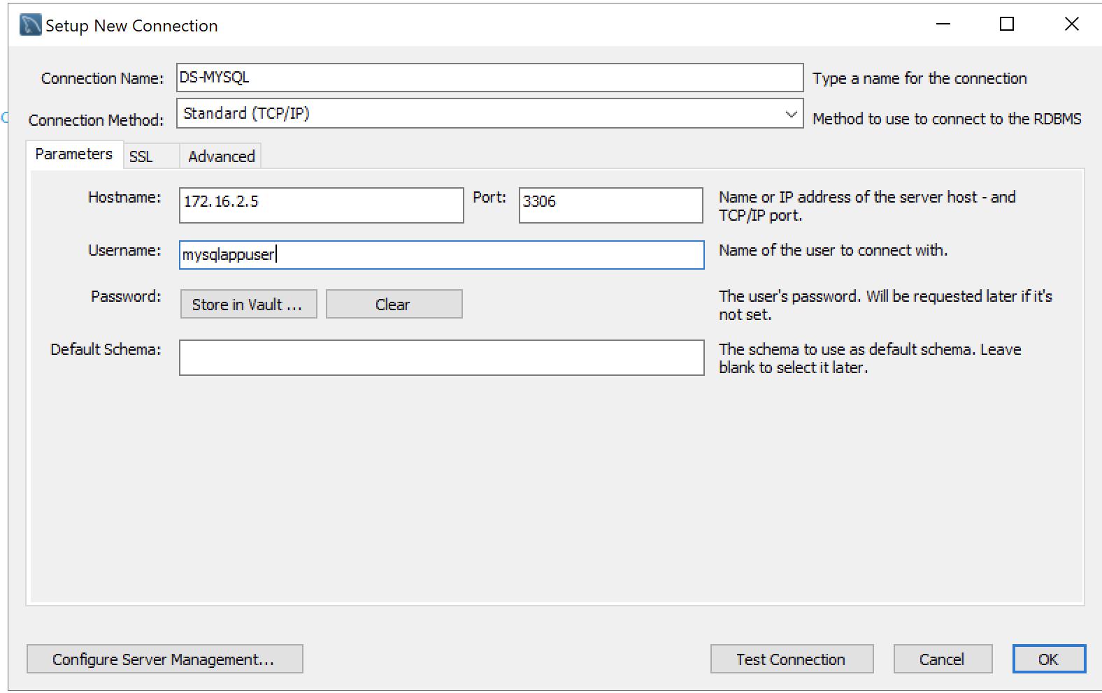**

If you have everything correctly then you should be able to connect to database successfully

**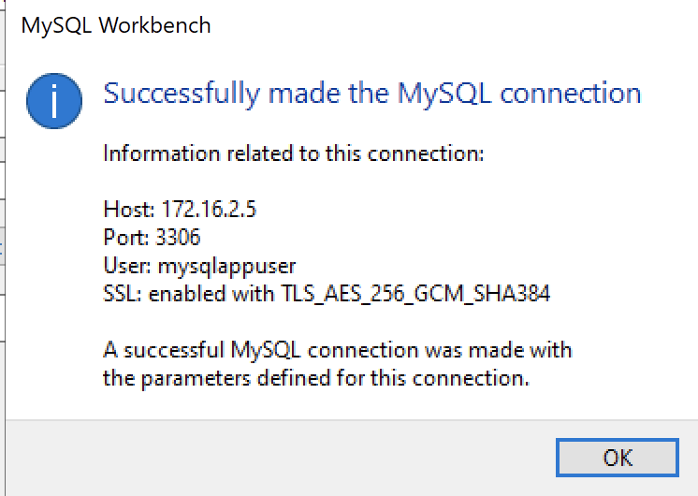**

**Day -3 Labs**

# Lab-1 - Deploy the On-Premises to Cloud Director Replication Appliance by Using the vSphere Client

**Objective and Tasks:** In the vSphere Client, you can deploy the On-Premises to Cloud Director Replication Appliance by using a single .ova file.

# Task 1: Deploy Appliance

1. Log in to the vCenter Server [**https://vc01.tanzu.lab/**](https://vc01.tanzu.lab/)by using the vSphere Client.
   1. User Name – [administrator@vsphere.onprem](mailto:administrator@vsphere.onprem)
   2. Password – VMware1!
2. Select Host **esx-09.tanzu.lab** on which we will deploy the On-Premises to Cloud Director Replication Appliance.
3. Right-click Host **esx-09.tanzu.lab** and from the drop-down menu select **Deploy OVF Template.**

The **Deploy OVF Template** wizard opens. The following steps depend on the vSphere version that you use.

1. On the **Select an OVF template** page, browse to the VMware-Cloud-Director-Availability-On-Premises-4.5.0.5855303-21231906fd\_OVF10.ova file location (Downloads) and click **Next.**
2. On the **Select, a name and folder** page, enter a name for the on-premises appliance as **VCDA-OnPrem,** select a deployment location, and click **Next**.
3. On the **Select a compute resource** page, select host **esx-09.tanzu.lab** to run the appliance on, and click **Next.**
4. On the **Review details** page, verify the OVF template details and click **Next**.
5. On the **License agreements** page, select the **I accept all license agreements** check box and click **Next**.
6. On the **Configuration**page, select the **On-Premises to Cloud Director Replication Appliance** deployment configuration for the appliance type and click **Next**.
7. On the **Select storage** page, select the virtual disk format as “**Thin Provision**” and select “**Datastore-local”** for the appliance and click **Next.**
8. On the **Select networks** page, select VM Network as **mgmt-vm** andclick **Next**.
9. On the **Customize template** page, customize the deployment properties of the on-premises appliance and click **Next.**
   1. Enter and confirm the initial password for the appliance root user as **“VMware1!”**
   2. Select the Enable SSH check box.
   3. In the **NTP Server section**, enter the NTP **server address** as **192.168.110.10**
   4. In the **Network Properties,** enter as below:
      1. HostName: vc-da.tanzu.lab
      2. Address: 192.168.110.43/24
      3. Gateway: 192.168.110.1
      4. DNS Server: 192.168.110.10
      5. Search Domain: tanzu.lab
10. On the **Ready to Complete** page, review the **settings**, and to begin the .ova installation process, click **Finish.**

# Task 2: Configure Appliance

1. In a Web browser, go to **https://192.168.110.43/ui/admin**
2. Log in by using the root user password that you set during the OVA deployment.

Since you log in to the appliance for the first time, you must change the initial root user password.

1. Enter the initial root user password (VMware1!) that you set during the OVA deployment.
2. Enter and confirm a new password (VMware@1234$).
3. Click on **Run the Initial setup wizard**

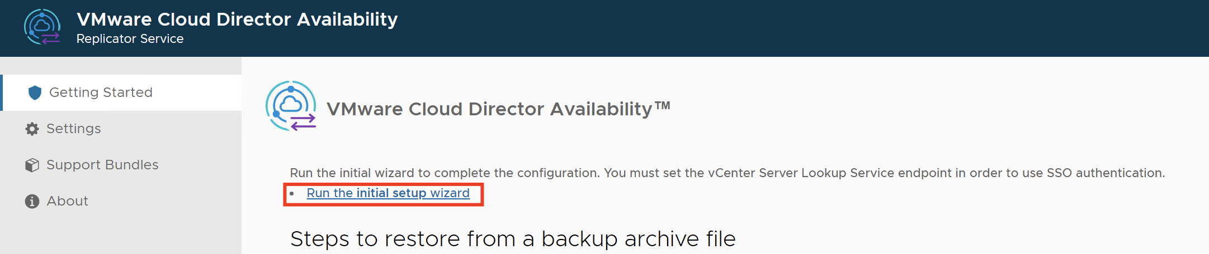

1. On the **Lookup Service page**, enter the connection details for the vCenter Server Lookup service
   1. **Lookup Service Address:** [**https://vc01.tanzu.lab:443/lookupservice/sdk**](https://vc01.tanzu.lab:443/lookupservice/sdk)
   2. **SSO Admin Username:** [administrator@vsphere.onprem](mailto:administrator@vsphere.onprem)
   3. **Password:** VMware1!
   4. To establish a connection with the vCenter Server Lookup service, click **Next**.
   5. Verify the thumbprint and accept the SSL certificate of the vCenter Server Lookup service.
2. On the **Site Details** page, enter a name that identifies this on-premises site to the cloud provider and click **Next**.
   1. Site Name: Stark-On-prem
3. On the **Cloud Service Details** page, pair the On-Premises to Cloud Director Replication Appliance with the cloud provider and click **Next**.
   1. **Service Endpoint address:** [**https://192.168.110.44:8048**](https://192.168.110.44:8048)
   2. Organization Admin: tony@stark
   3. Organization Password: VMware1!
   4. **Allow access from Cloud: Activated access from the cloud site:**
   5. verify the thumbprint and accept the SSL certificate of the Service Endpoint.
4. On the **Ready To Complete** page, configure the on-premises local placement, and to complete the wizard click **Finish**.
5. This will open the Complete the **Configure Placement** wizard.
   1. **VM Folder: Discovered virtual machine**
   2. **Compute Resource**: Workload
   3. **Default Network: Leave Default**
   4. **Datastore: Leave Default**
6. On the **Ready To Complete** page, verify that the selected configuration is correct and click **Finish**.
7. Go back to Home page of VCDA and see the health, it should be like as below:

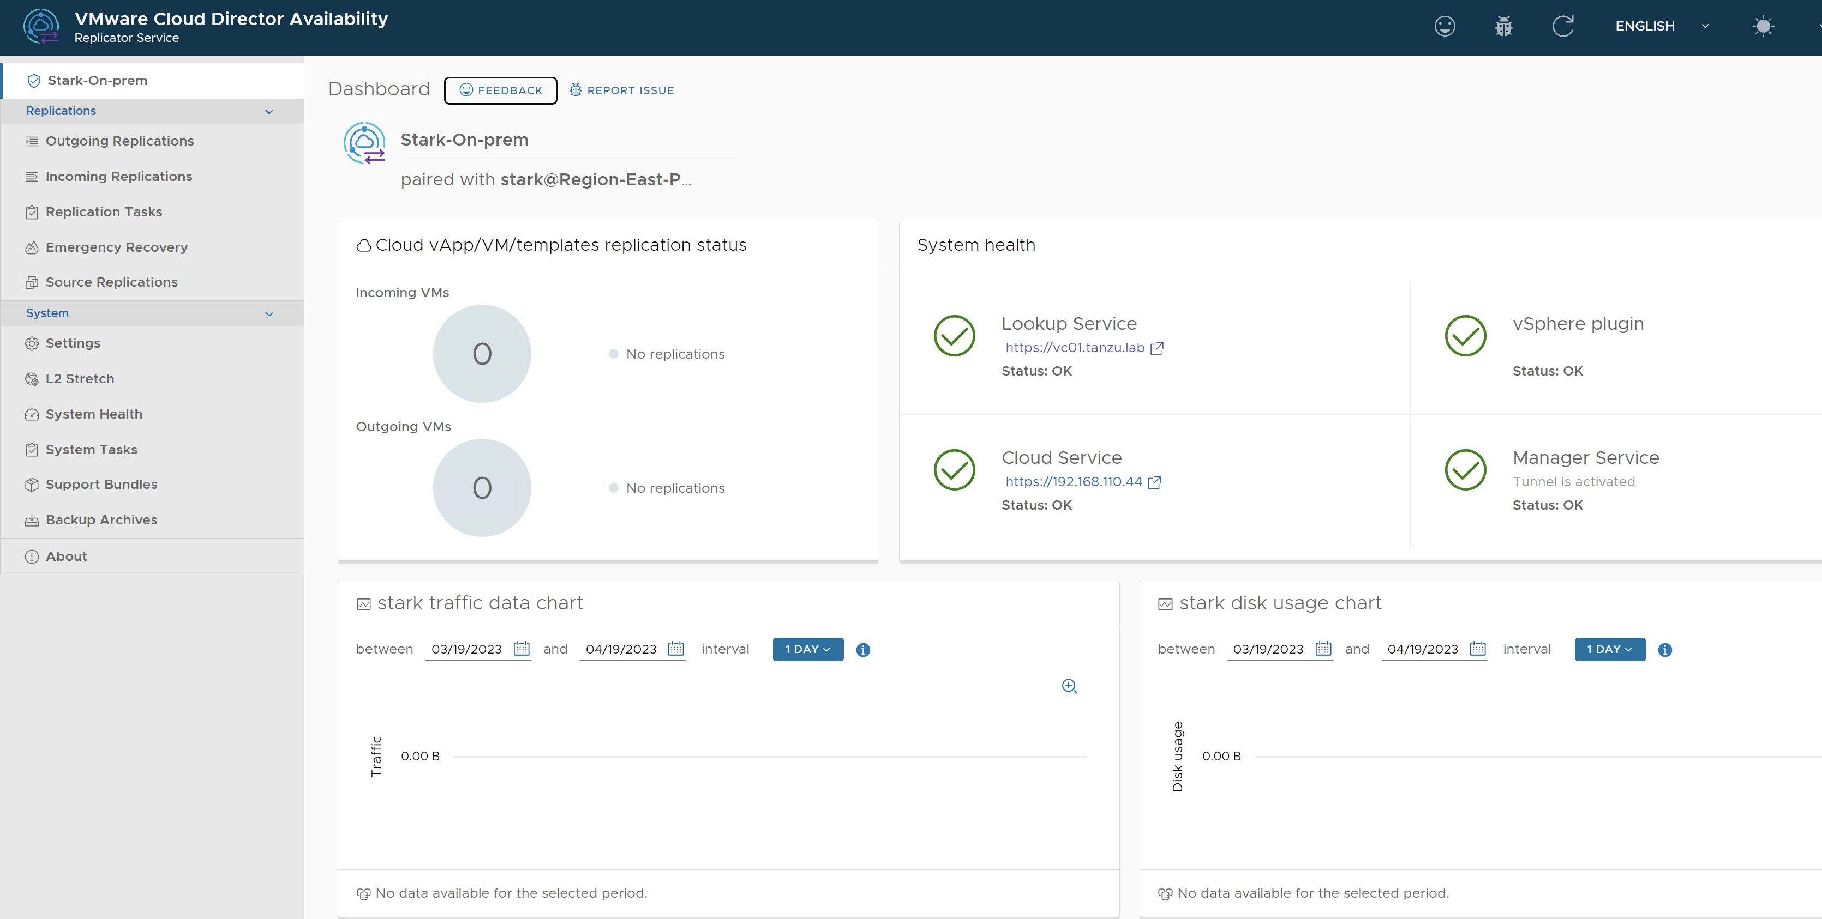

# Task 3: Create Protection and Migration

**Protection** - Configure new protection to replicate the workload from one site to another while keeping it running in the source site. After a successful replication, if the source site becomes unavailable, you can fail over and power on the protected workload in the destination site.

Login to vCenter - <https://vc01.tanzu.lab/ui/>

Username: [administrator@vsphere.onprem](mailto:administrator@vsphere.onprem)

Password: VMware1!

In the **vSphere** Client, click **Menu** and select **Cloud Provider DR and Migration**

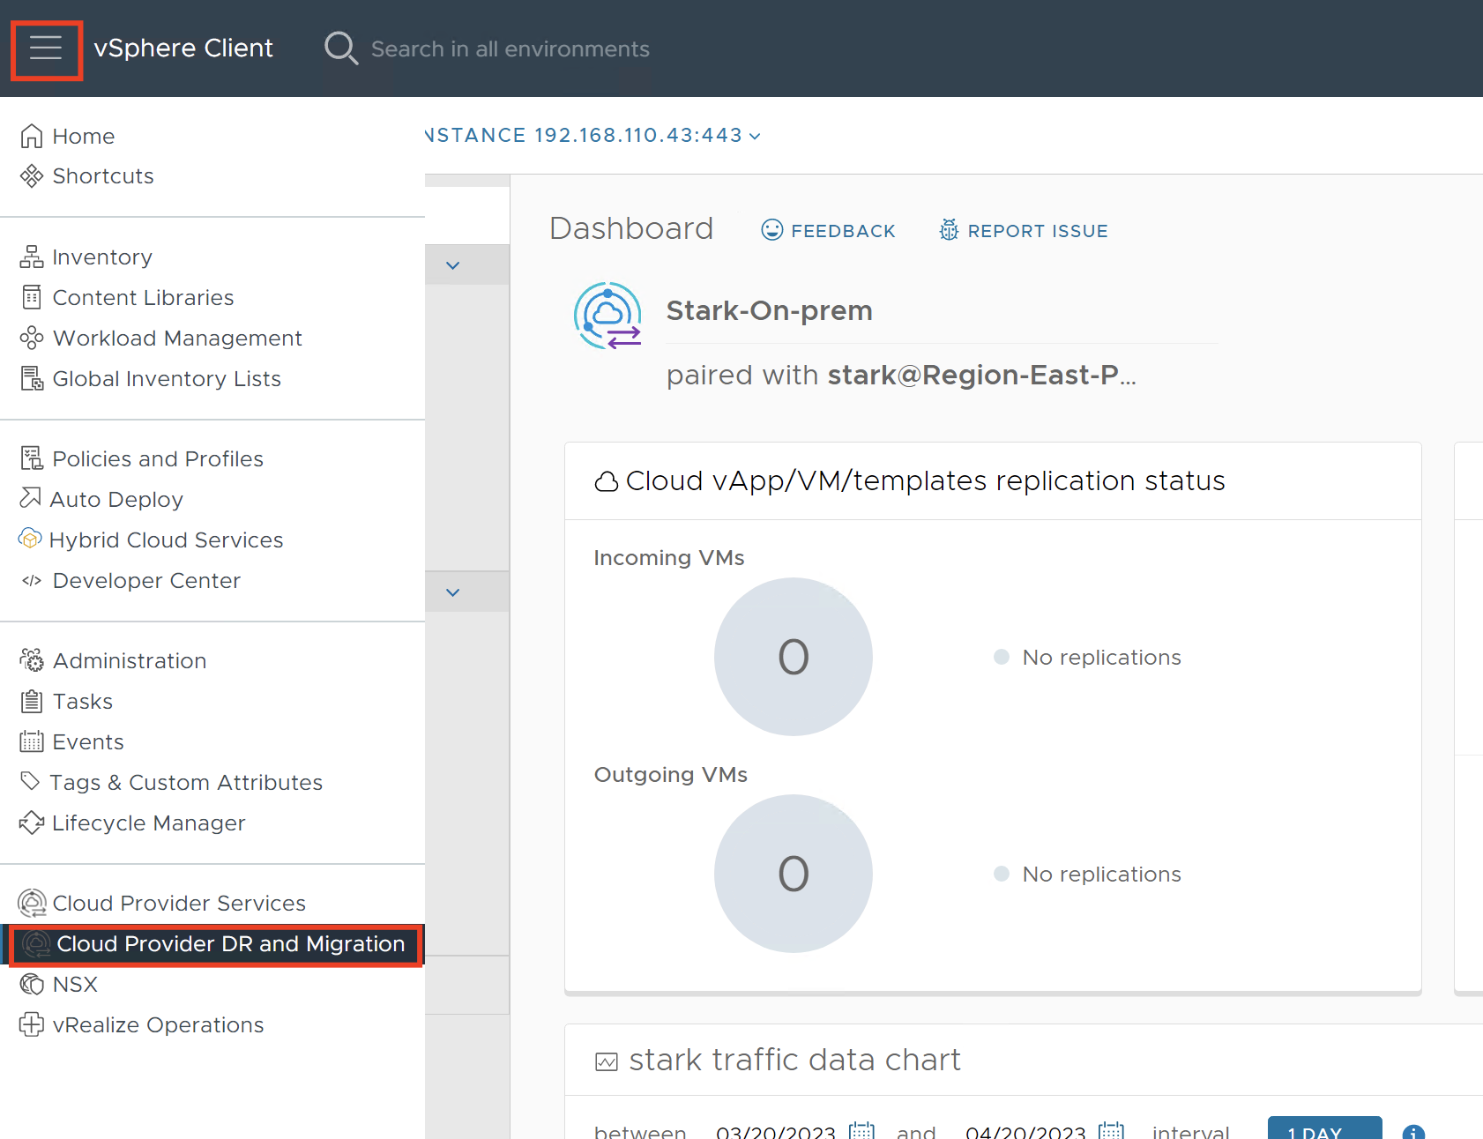

1. In the left pane, choose a replication direction by clicking on **Outgoing Replications**.
2. To configure the migration with all migration settings, click **All Actions** > **New Replication**.
3. Login with Username: tony@stark and Password: VMware1!
4. On the **Source VMs** page, select the source virtual machines **Web01**, then click **Next**.
5. On the **Destination VDC and Storage policy** page, select the destination virtual data center as **“vmware-cloud”** and the storage policy as **“lab-shared-storage”** for placing the recovered workloads, then click **Next**.
6. On the **Settings** page, configure the following protection settings:
   1. **Use SLA profile:** select **Configure settings manually** then select the following SLA settings
   2. **Target recovery point objective (RPO): 1 Min**
   3. **Retention policy for point in time instances: Enable**
   4. **Retention settings as below:**
      1. 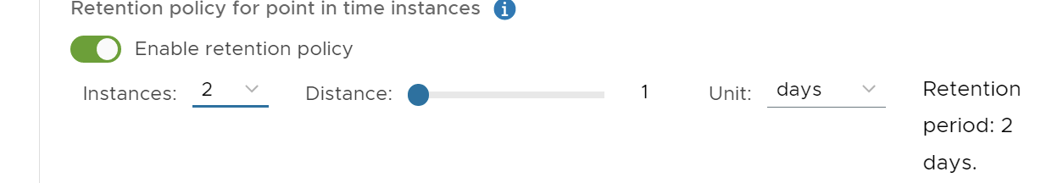
   5. **Compress replication traffic: Enable**
   6. **Leave every other thing as Default**
   7. On the **Ready to complete** page, verify that the protection settings are correct, then click **Finish**.
   8. Login to VCD tenant URL <https://vcd.tanzu.lab/tenant/stark/>
      1. Username: tony
      2. Password: VMware1!
   9. Click on “Availability” (in-case page does not open, trust certificate of the URL)
   10. 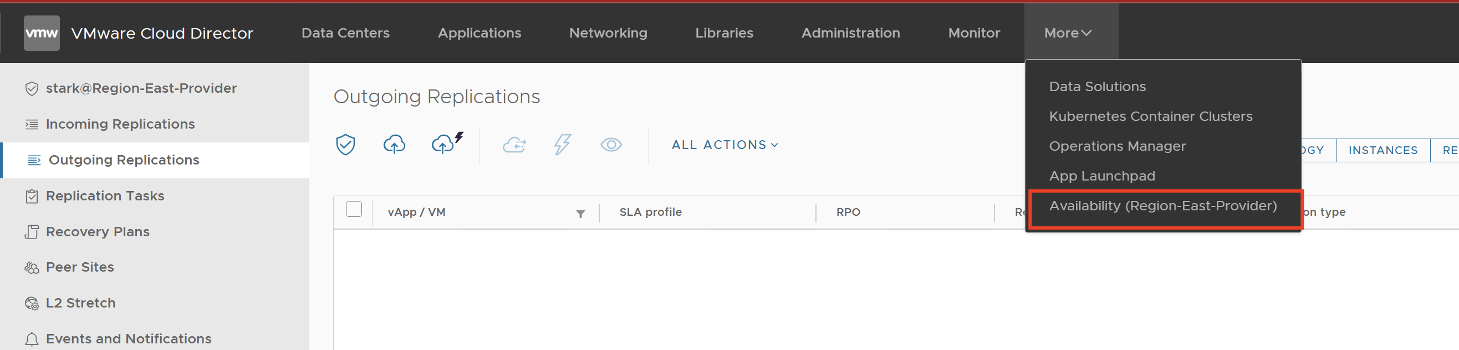
   11. You should see Web01 is being protected on Cloud

**Migration** - Configure a new migration to replicate the workload from one site to another. After a successful replication, you can migrate the workload to a remote site for running it in the destination site.

Login to vCenter - <https://vc01.tanzu.lab/ui/>

Username: [administrator@vsphere.onprem](mailto:administrator@vsphere.onprem)

Password: VMware1!

In the **vSphere** Client, click **Menu** and select **Cloud Provider DR and Migration**



1. In the left pane, choose a replication direction by clicking on **Outgoing Replications**.
2. To configure the migration with all migration settings, click **All Actions** > **New migration**.
3. Login with Username: tony@stark and Password: VMware1!
4. On the **Source VMs** page, select the source virtual machines **Web02**, then click **Next**.
5. On the **Destination VDC and Storage policy** page, select the destination virtual data center as **“vmware-cloud”** and the storage policy as **“lab-shared-storage”** for placing the recovered workloads, then click **Next**.
6. On the **Settings** page, configure the following migration settings:
   1. **Compress replication traffic: Enable**
   2. **Leave everything as Default, then click Next**
7. On the **Ready to complete** page, verify that the migration settings are correct, then click **Finish**.
8. Login to VCD tenant URL <https://vcd.tanzu.lab/tenant/stark/>
   * 1. Username: tony
     2. Password: VMware1!
9. Click on “Availability” (in-case page does not open, trust certificate of the URL)
   1. 
   2. You should see Web02 is being migrated on Cloud

# 

# 

# Glossary